The use of historical information to enhance your genealogy: your family history is more than just names in a family tree.
Introduction
Our families all lived interesting lives and may have been involved in adventures or enterprises that might astound us. Each member of our family is much more than just a name on a family tree. It is fascinating the information and stories that can be found in historical documents.
Our Nova Scotia ancestors migrated to this province from a variety of locations on both sides of the Atlantic. They may have come directly from the British Isles or from Continental Europe while others arrived in the Thirteen Colonies before making their way to Nova Scotia. Making a living in Nova Scotia required the development of a variety of skills, ranging from blacksmithing, fishing and seafaring to lumbering and agricultural endeavours. So, it is impossible to say that a particular ancestor was mainly engaged in only one activity, such as farming. It is by investigating numerous records that we begin to get a better idea of the depth of knowledge and the skills possessed by our ancestors.

Primary Sources of Information that are Sometimes Underutilized.

Note: Library and Archives Canada web site ( http://www.collectionscanada.gc.ca/education/008-3010-e.html ) provides information on the concept of primary and secondary sources.

1) County Registry of Deeds Records
- Land Transactions
- Boundaries of School Sections in the District of Parrsborough Township
- The Three so-called "Land Grant Books"

2) County Probate Records,

3) Nova Scotia Archives & Records Management (formerly Public Archives of Nova Scotia).
- Early Land Grant Petitions
- Nova Scotia Statutes at Large (on line 1758 to 1835).
- Minutes of the Nova Scotia Council.
- Journal and Proceedings of the House of Assembly.
- Journal and Proceedings of her Majesty’s Legislative Council of the Province of Nova Scotia.

4) Other Government of Nova Scotia Documents.
- Crown Land Index Maps
- The Crown Land Information Management Centre

Suite 501, Founders Square, 1701Hollis St, Halifax
Phone: (902)424-2818
Crownland@gov.ns.ca
  - Example Document
  - Index for the Cumberland County Portfolio
  - The Advocate Grant: A 1784 Document found in the “Cumberland County Portfolio”
  - A drawing showing the location of the Advocate Grant relative to the apple River Grant and the Parrsborough Shore Grants.

5) The Industrial Section of the 1871 Census

The Library and Archives Canada web site titled catalogue of Census Returns on Microfilm 1666-1901 states that the most extensive and most comprehensive census records in their custody are those for the year 1871. Each enumeration district in the 1871 census contains the following nine sections.

1. Nominal return of the living.
2. Nominal return of the deaths within the last twelve months.
3. Return of public institutions, real and personal estate.
4. Return of cultivated land, of field products and of plants and fruits.
5. Live stock, animal products, home-made fabrics and furs.
6. Return of industrial establishments. This section is known as the "Industrial Section of the 1871 Census".
7. Return of products of the forest.
8. Return of shipping and fisheries.
9. Return of mineral products.

Section six, industrial establishments, is a valuable source of material for those researching nineteenth century shipyards and sawmills.

6) Theses,
- Alexandra Montgomery
“An Unsettled Plantation: Nova Scotia’s New Englanders and the Creation of a British Colony, 1759-1776”

Chapter 4 of this Dalhousie University Master of Arts thesis is devoted to an eighteenth century land grant region of Parrsborough Township called the Philadelphia Township. The author, Alexandra L. Montgomery, used archival material called the Ball Families: Papers, 1676-1879. These documents involving Nova Scotia history are located in Philadelphia at the library of the Historical Society of Pennsylvania.
- David R. Stanley.
Nova Scotia’s Spencer’s Island Company, 1880-1895: A case Study in Post-Confederation Entrepreneurial Success
Abstract:

The Spencer’s Island Company (SIC) was established in 1880, following the collapse of the hamlet’s sole shipbuilding and storekeeping partnership. Its members were highly community oriented, and their greatest manufacturing capability was the transformation of trees into ships.

The company’s development coincided with Atlantic Canada’s rapid retreat from the maritime sector, a trend which intensified following the national policy’s introduction in 1879. Other Minas Basin entrepreneurs also expanded their fleets during the 1880s, to such an extent that the Basin accounted for more than a quarter of all ocean-going vessels registered in the Maritimes by the early 1890s.

New York merchants, led by J. F. Whitney and Company, were an important source of capital for ships built by SIC, and others in the region. Their investments, facilitated by mortgages registered against officially shares owned by merchants of the British Empire, contributed to this sub-region’s divergence from the Atlantic Canadian norm.

7) Shipping Registers

8) Faribault- Fletcher Geological Survey of Canada Maps

The Faribault-Fletcher GSC (Geological Survey of Canada) maps of Nova Scotia provide, in addition to information on mineral resources, such details as the locations of shipyards, sawmills, grindstone quarries, dams, dykes, fresh water meadows, lumber camps, piers, schools, graveyards, and villages no longer in existence. These maps have a precision and accuracy considered to be of high quality, even by today’s standards.Fortunately these valuable documents can be downloaded free from the Natural Resources Canada website
http://www.nrcan.gc.ca/library/6283
When this site opens select the link GEOSCAN located in the center of the page and below the heading "Resources". A box marked Basic Search will then open. In this box type: Faribault-Fletcher Geological Maps . A window containing an icon for each Faribault-Fletcher Geological Map will appear and each icon allows one to download in PDF or JPEG2000. A useful finding aid in the form of a graphical index is located at

http://www.versicolor.ca/kerr/IndexFaribaultFletcherGSCmaps.JPG

9) The Haldimand Papers at Library and Archives Canada

Examples Illustrating the Types of Information Found in the Registry of Deeds Office
Land Transactions
A) Heirs of Minor Allen Estate. This type of deed names the heirs of a deceased landholder.

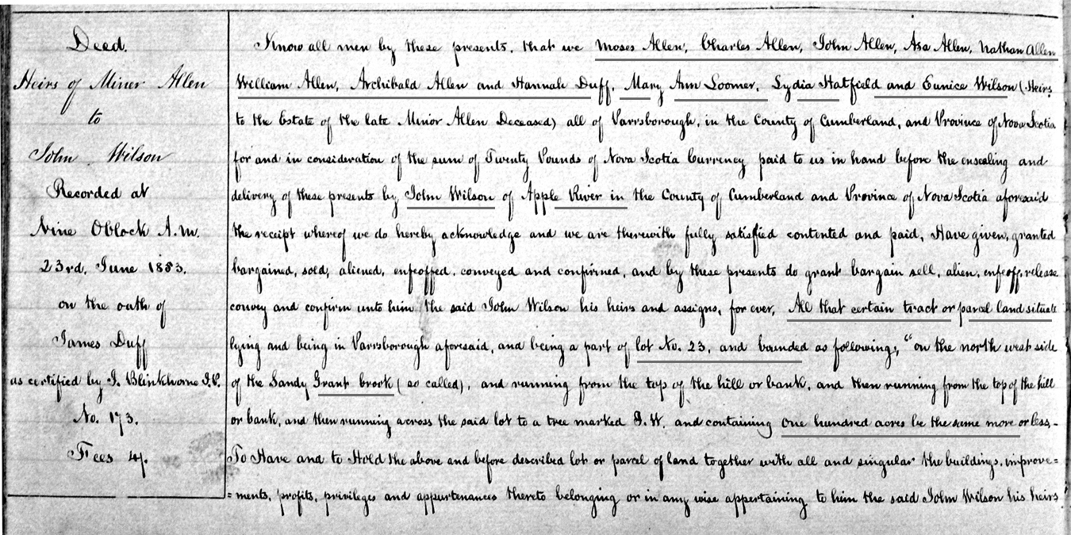

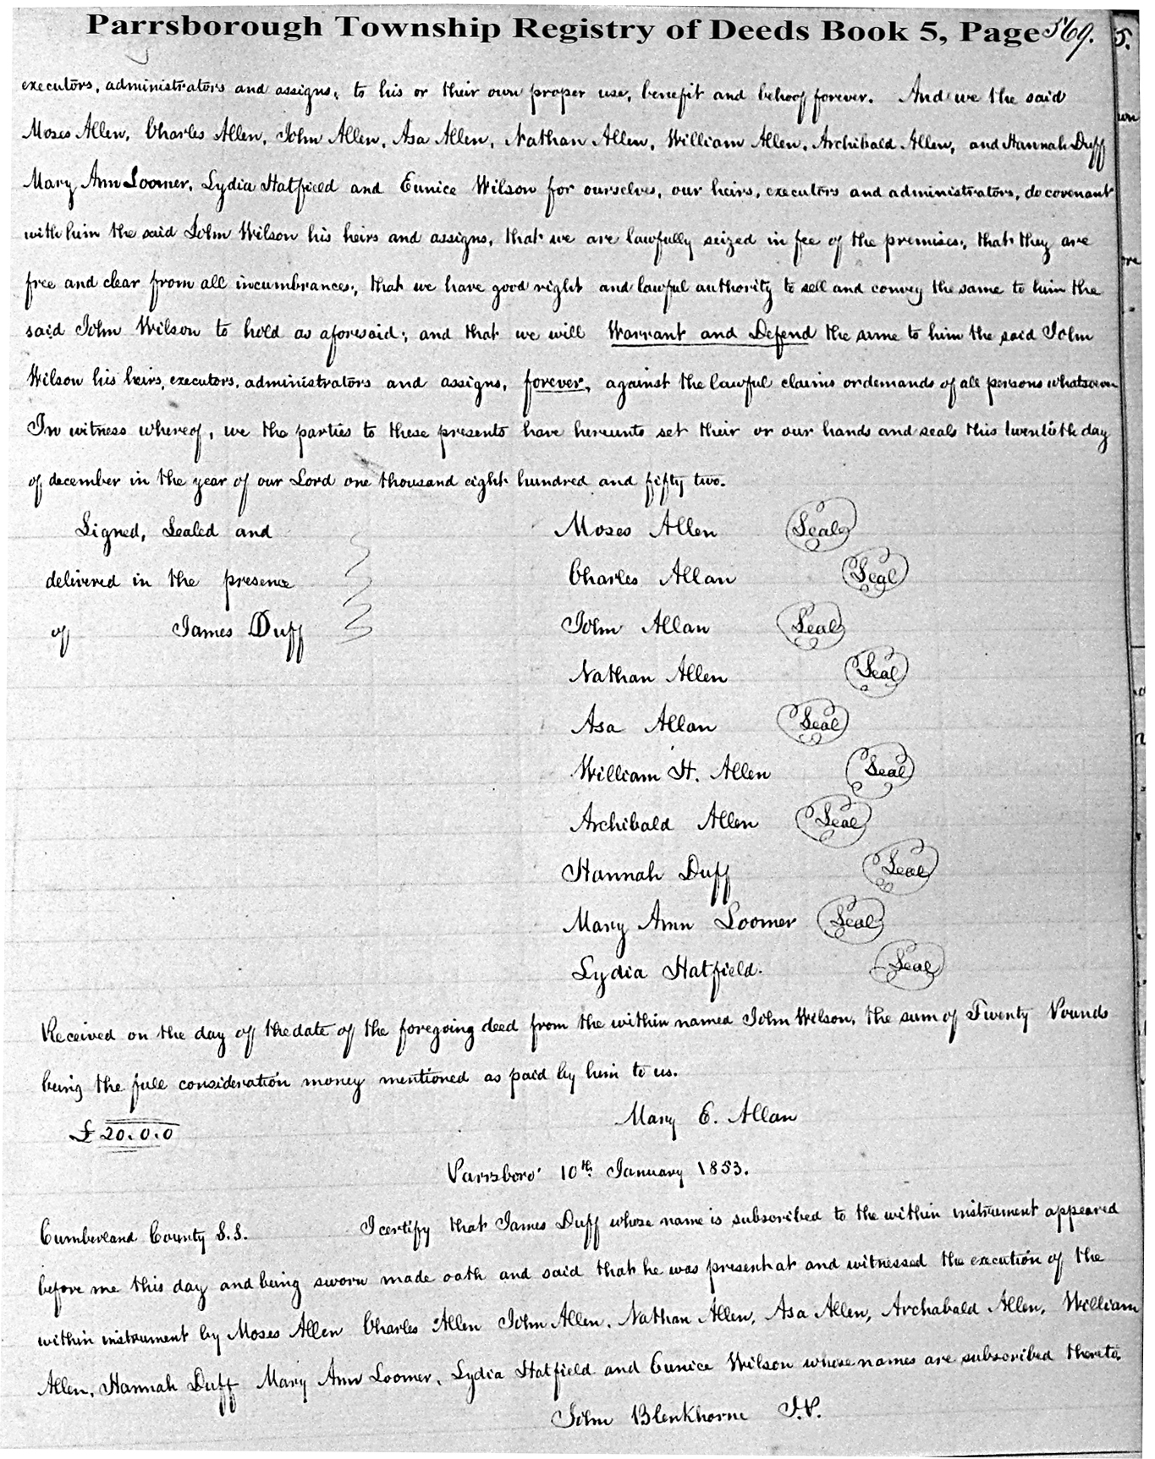

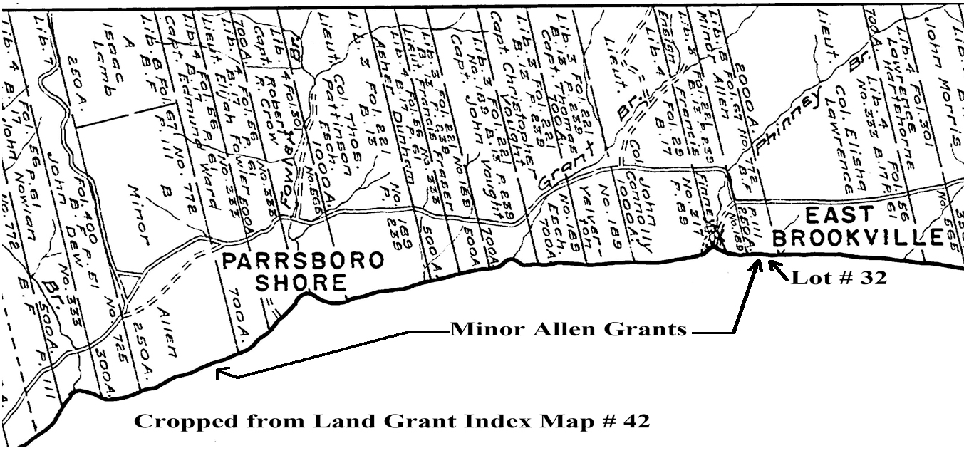

B) Deeds that contain drawings.

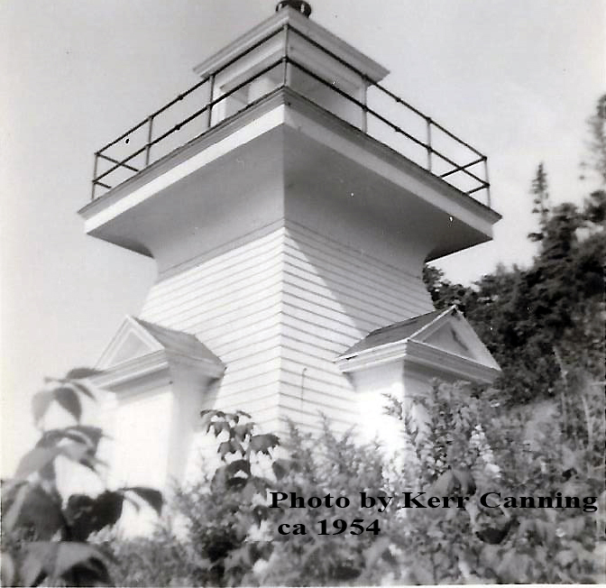

Port Greville Range Light

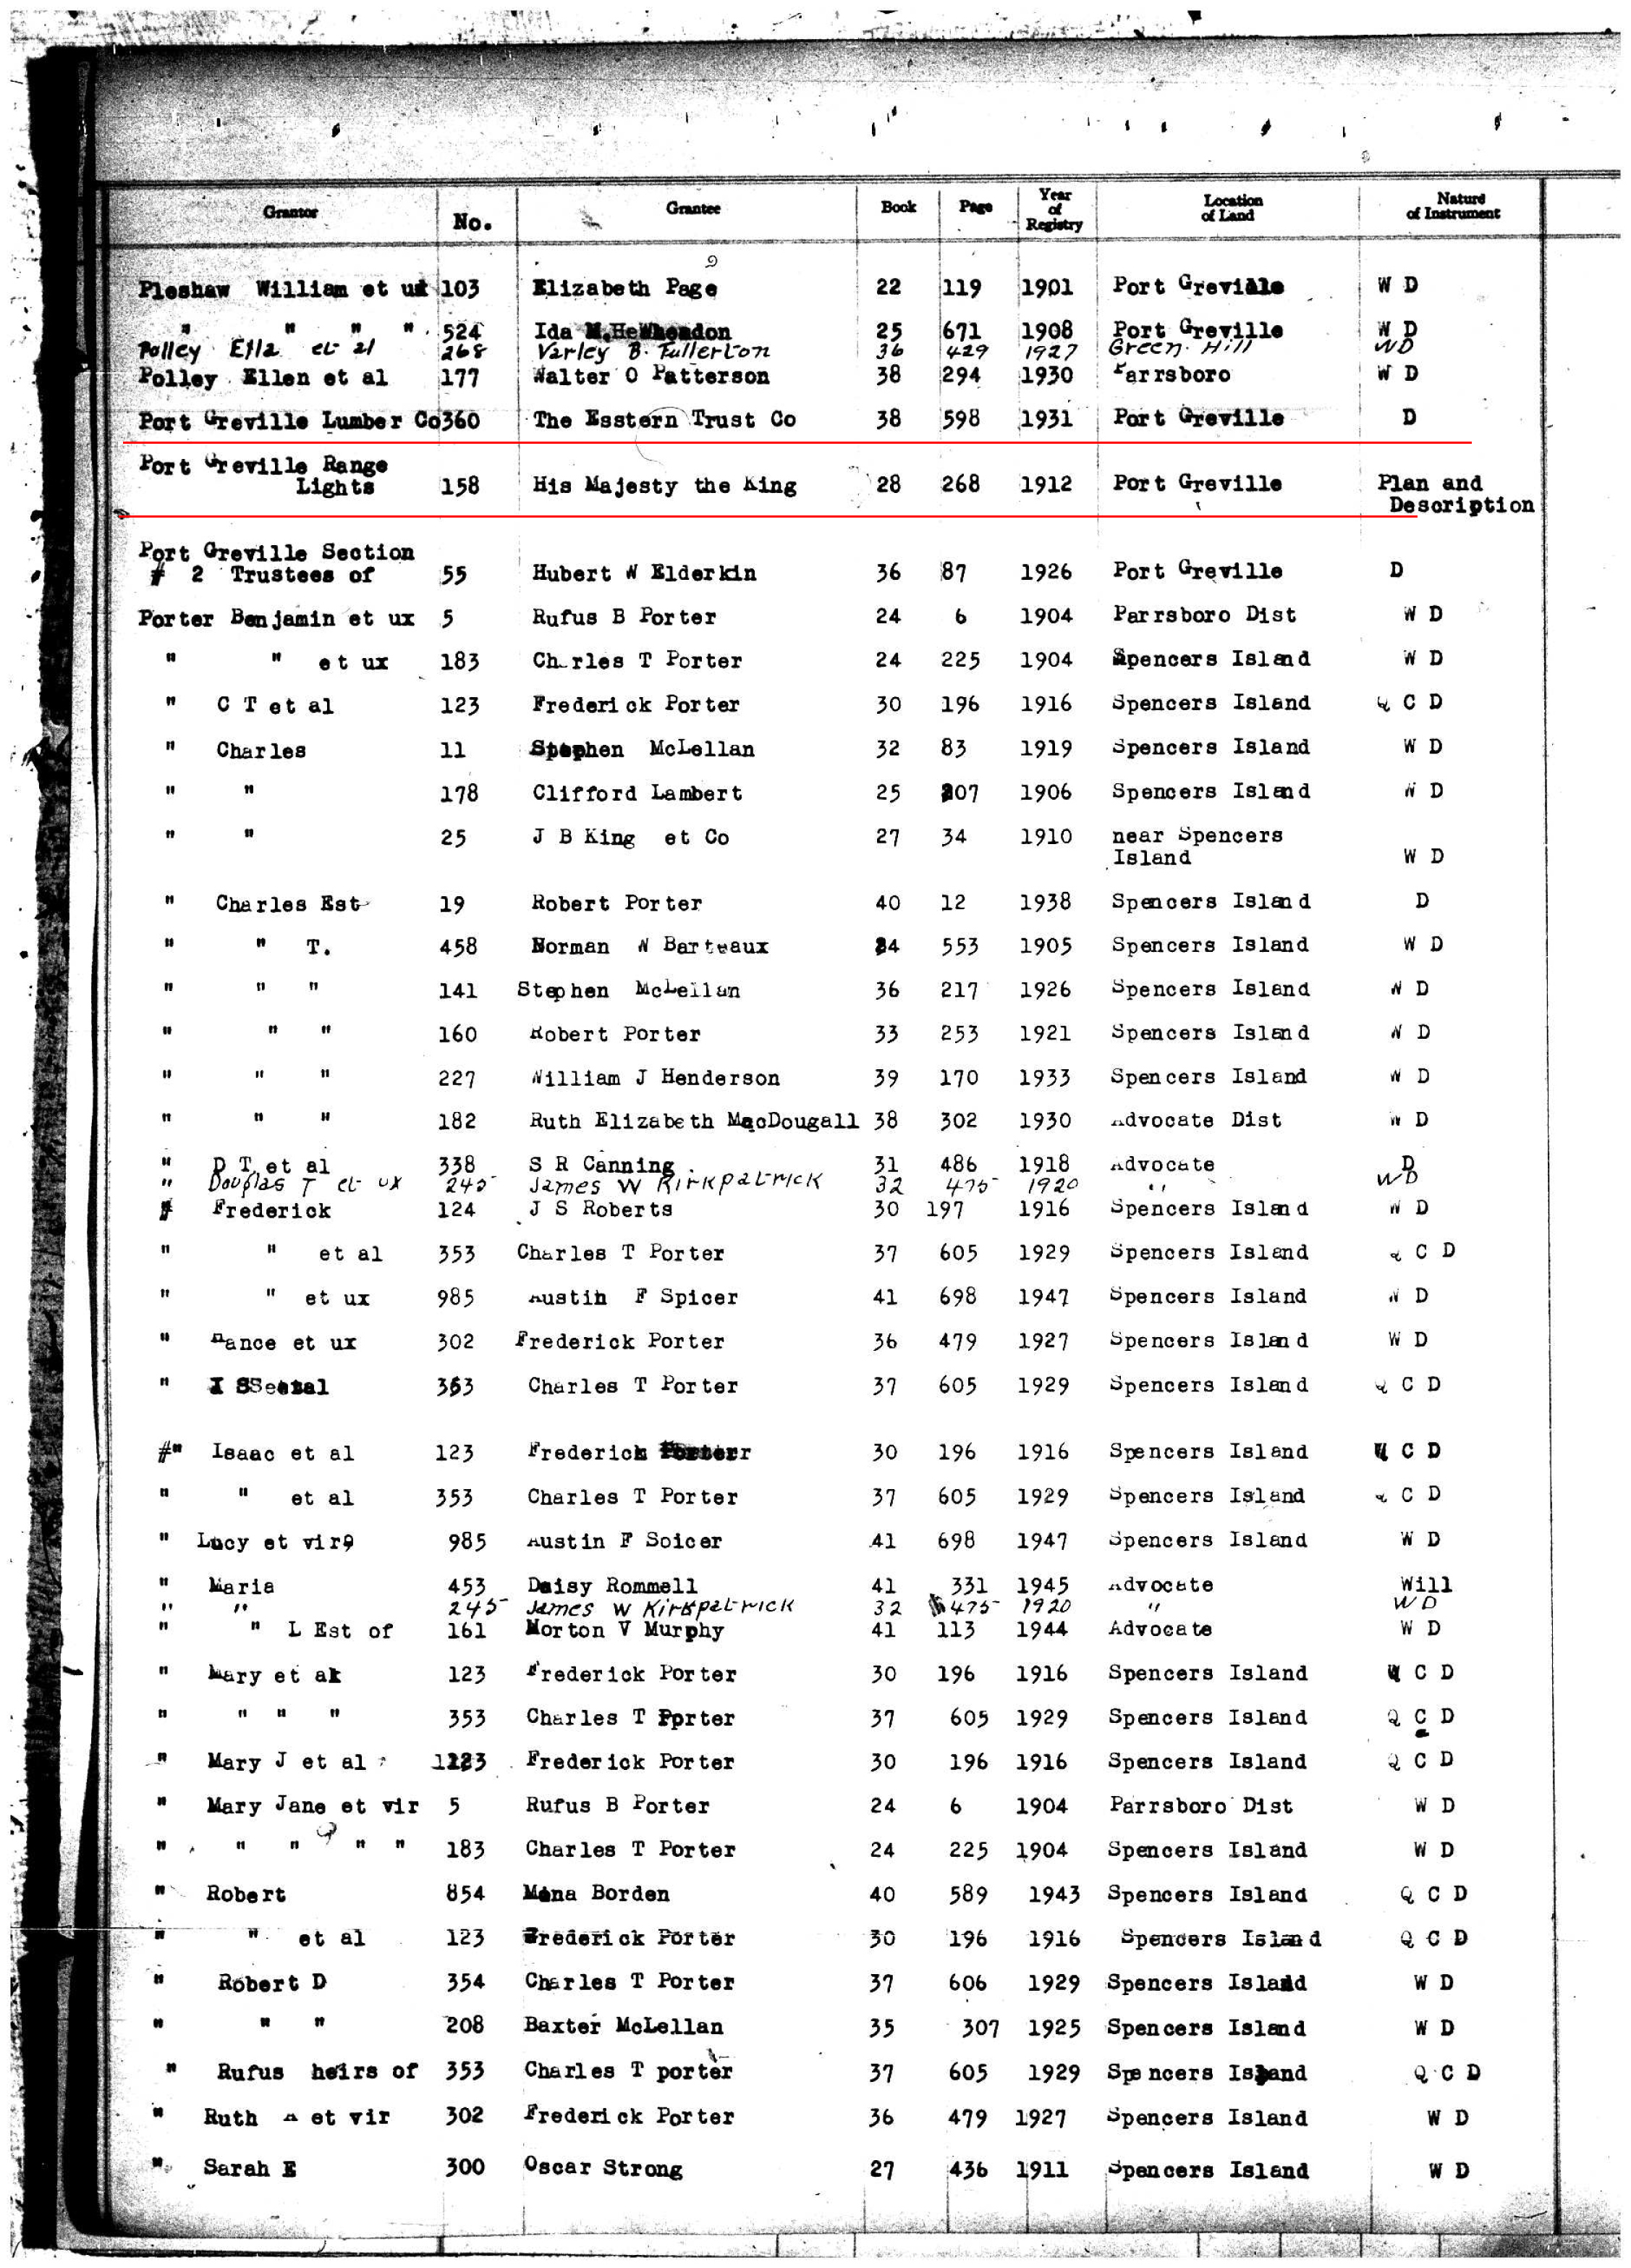

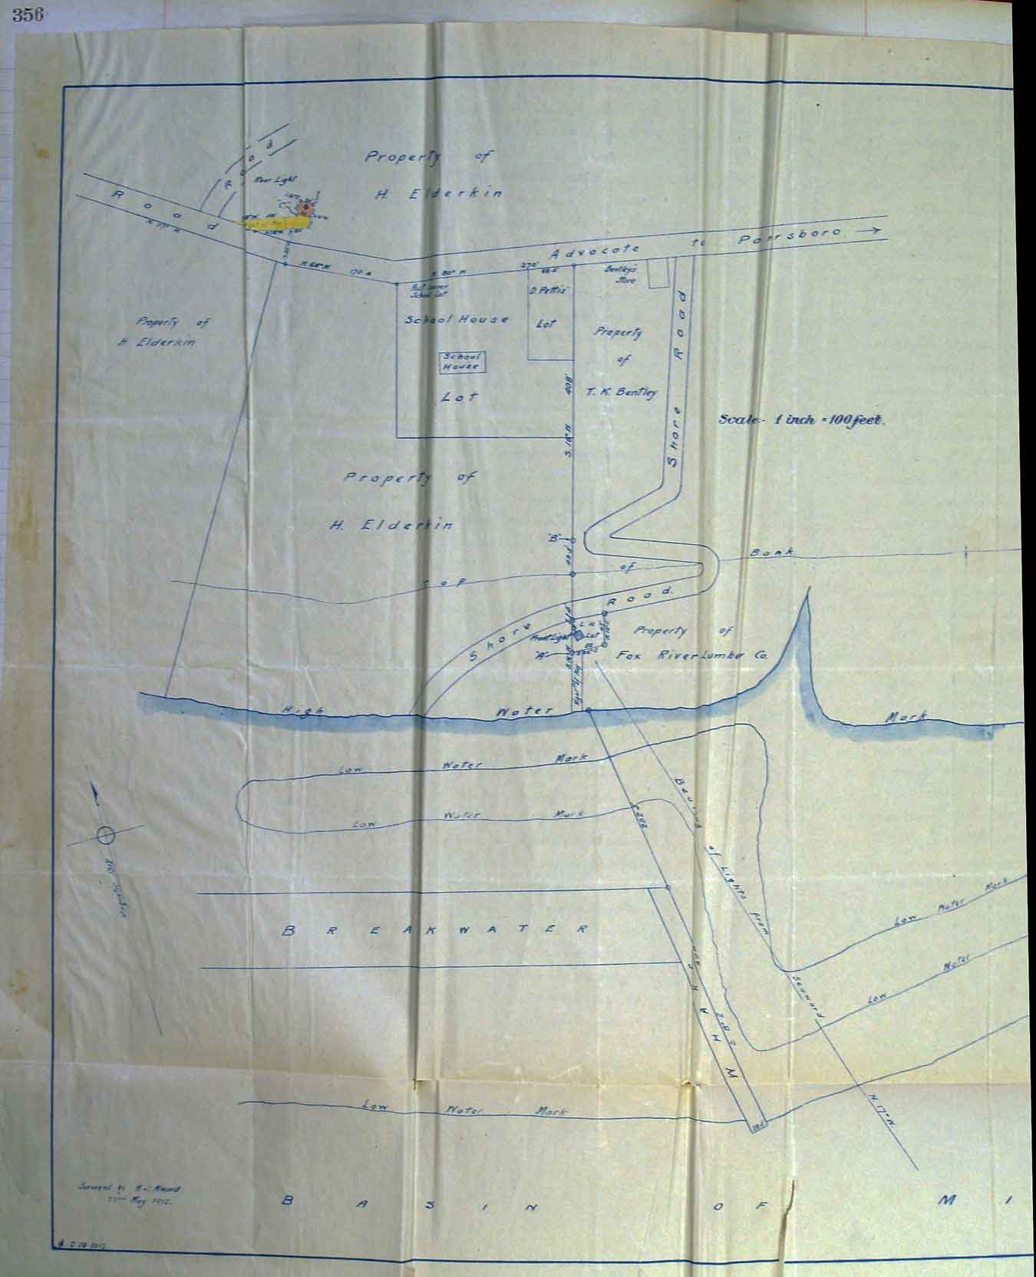

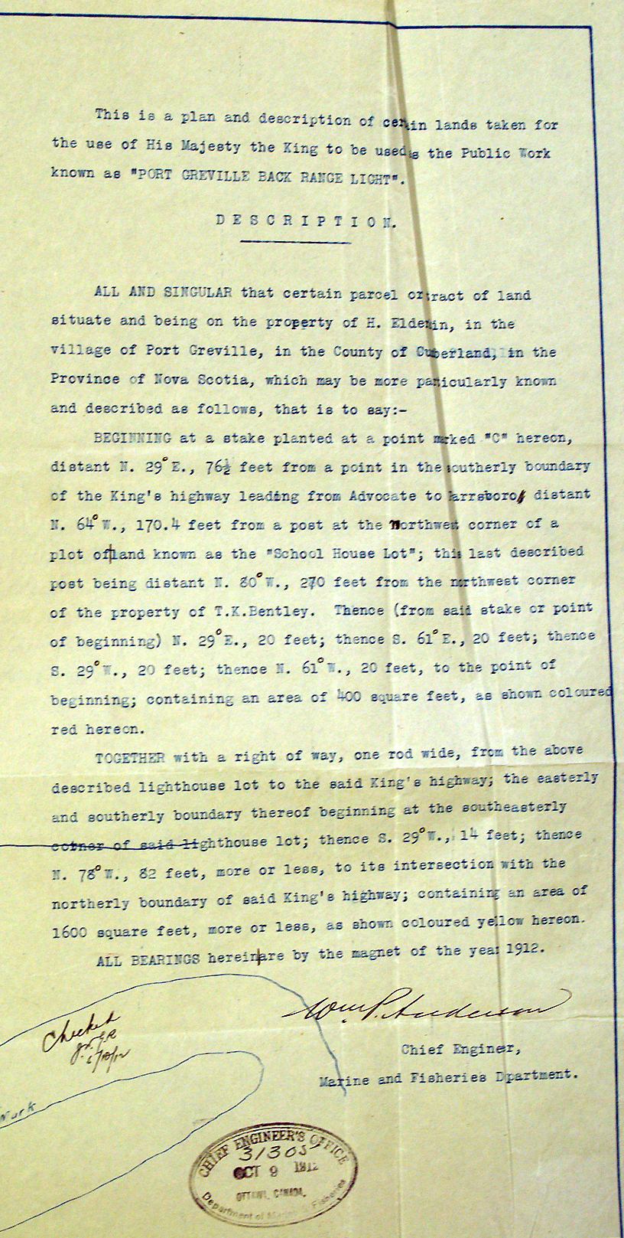

C) The brothers Hugh and Alexander Fullerton: An old story from Fox River.

The focus of the Hugh and Alexander Fullerton story, at least in the past, is outlined in a section of the newspaper article in Fig.C1.

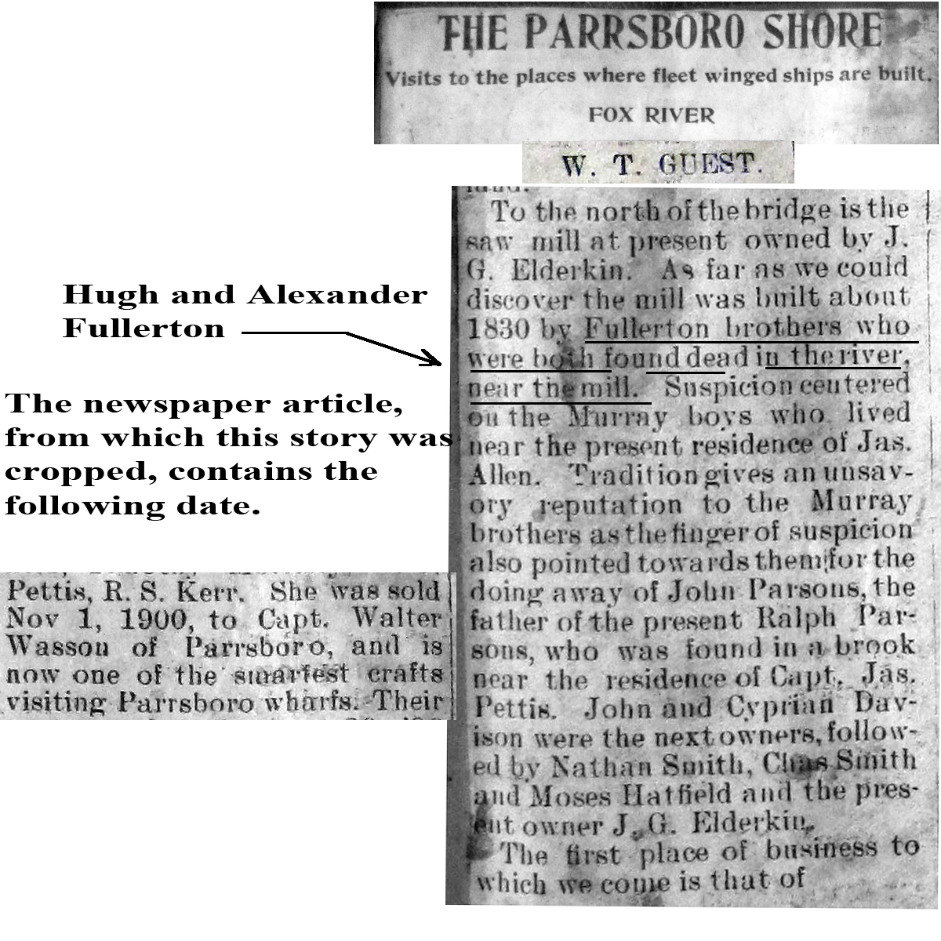

Fig. C1

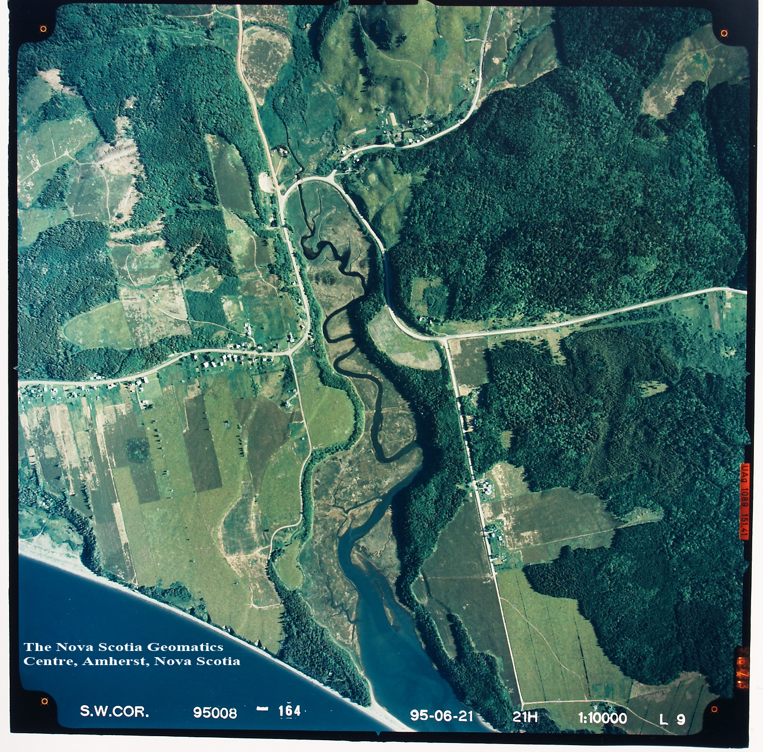

Fig.C2: An aerial photograph of the river where both brothers were supposedly found dead.

Several years ago I thought it would be interesting to search for land transactions in the Parrsborough Township Deed Books involving Fullertons living in Fox River. My search found the deed below and the contents were a surprise.

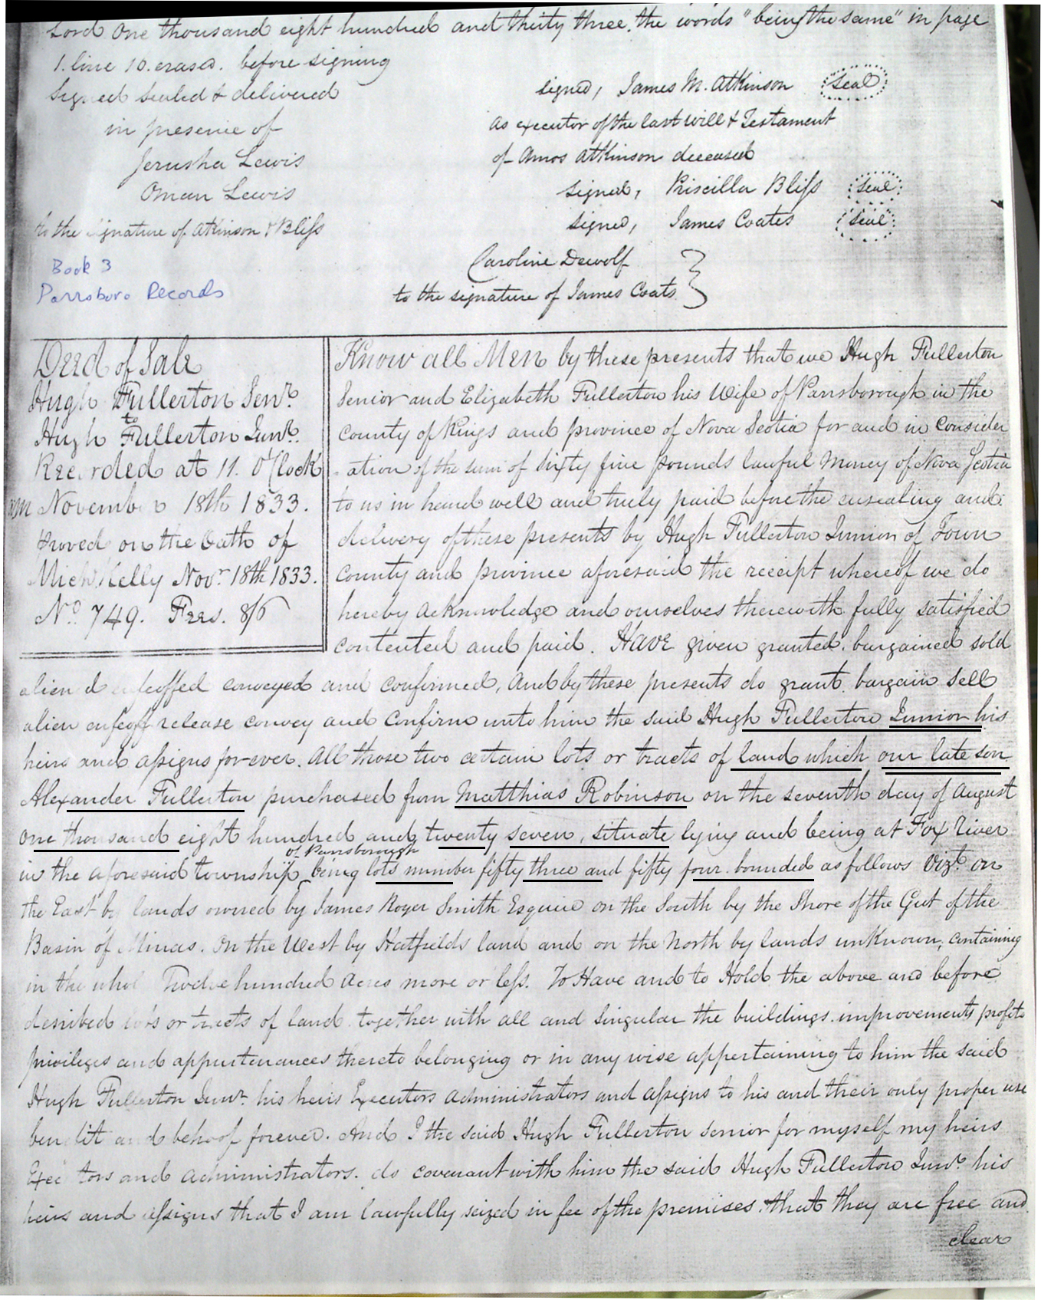

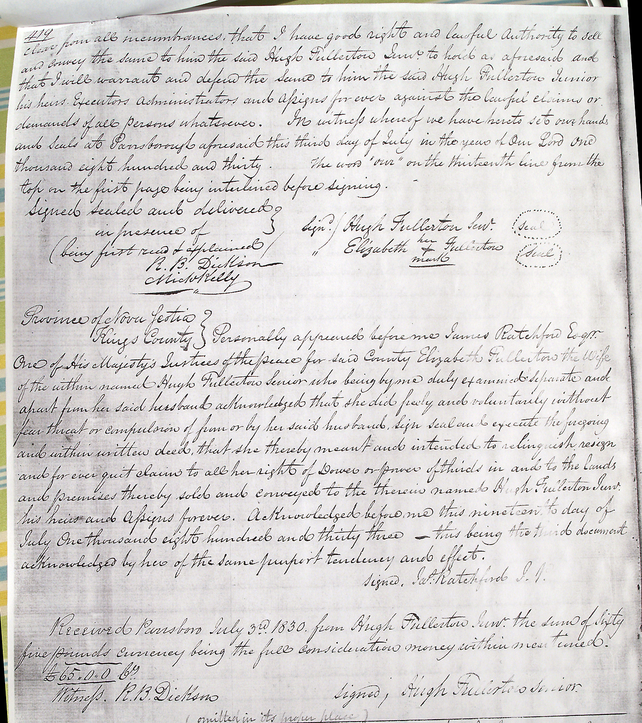

Fig. C3

The lots mentioned in the above deed are indicated on the Land Grant Index below. Further searching revealed that Alexander Fullerton Senr. was the executor his son's estate. As well Alexander Fullerton Senr. And his remaining son Hugh Fullerton abandoned Fox River and moved to the hills of Canaan where they received a land grant on the road to Cranberry Lake. See Fig.C4

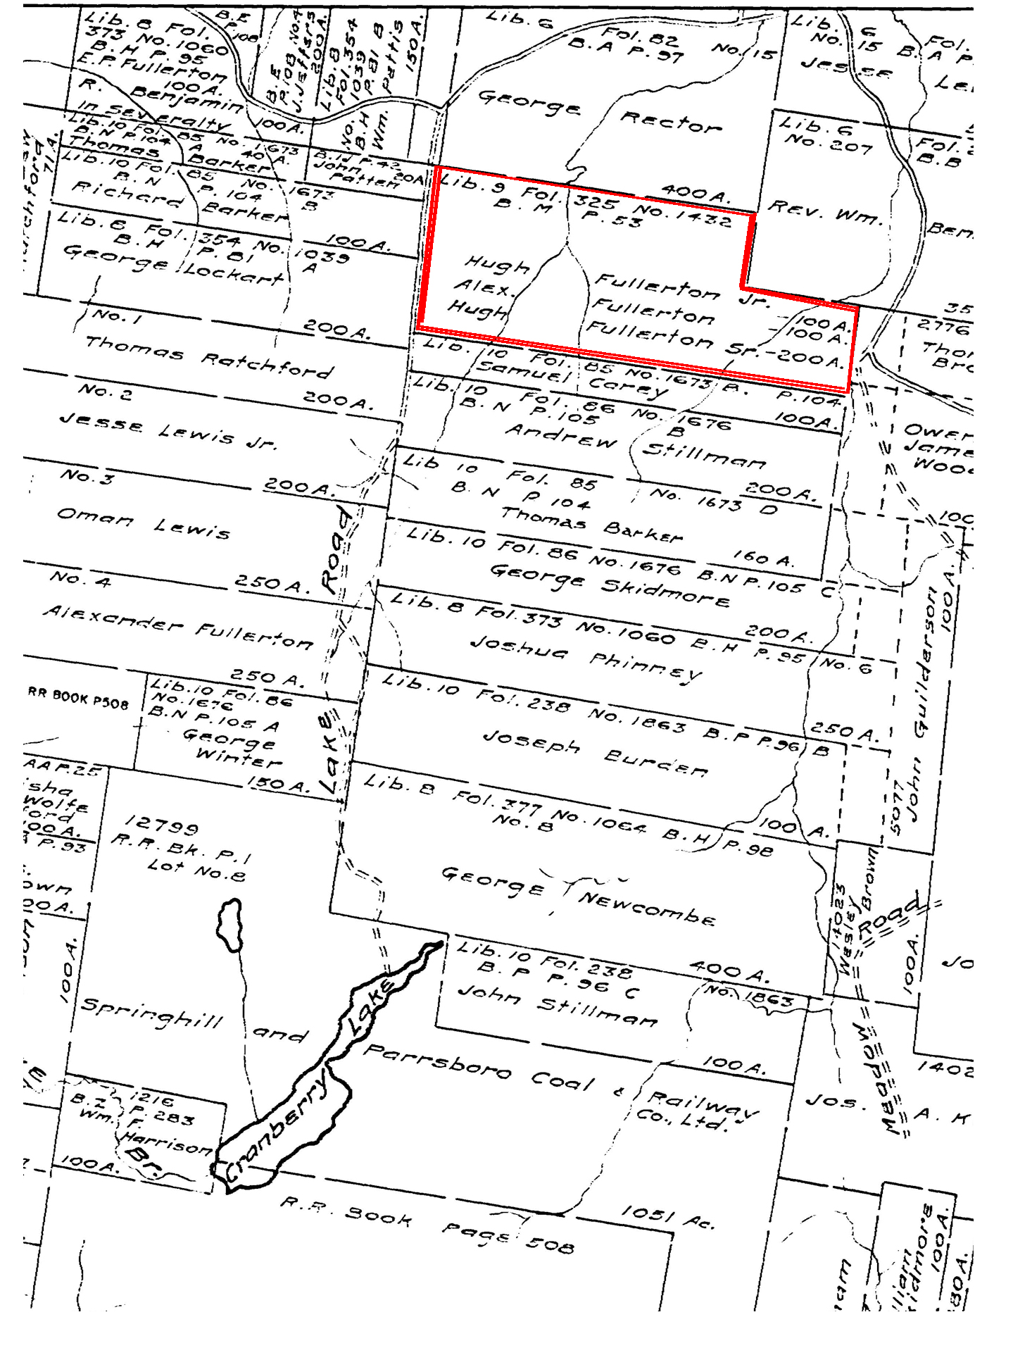

Gig. C4

