Using Information Produced by the Geological Survey of Canada to Identify Possible Archeological Sites in Nova Scotia:
Part One

By Kerr Canning

Introduction

This two-part paper describes publications of the Geological Survey of Canada (GSC) that may be useful in identifying archeological sites in Nova Scotia. The GSC published a wide variety of maps, photographs, and reports. The GSC maps of Nova Scotia provide, in addition to information on mineral resources, such details as the locations of shipyards, sawmills, grindstone quarries, dams, dykes, fresh water meadows, lumber camps, piers, schools, graveyards, and villages no longer in existence. These maps have a precision and accuracy considered to be of high quality, even by today’s standards. The GSC photograph collection, dating at least from the 1870’s, contains images that provide information on people and on physical structures that have long disappeared. When the annual reports depict the geology of an area, these geological formations are often located in or near a community. Sometimes when this happens, useful information about the community is included with the geological descriptions. Dams, wharves, dykes and other man made structures are mentioned and sometimes described. Comments about the early lumbering and agriculture activities may be included. There may be a short statement documenting the types of timber that are still plentiful and the species, such as pine, that have all but disappeared. Agricultural comments may discuss hay production on large fresh water meadows or mention may be made that French dykes have been replaced by dykes that “cross the brooks at their mouths instead of turning up along them”. ¹ There may even be a recommendation stating that adding marsh mud could easily reclaim barren land near the shore. ¹

Part One of this paper will cover the multicoloured maps published by the GSC and Part Two, which will appear in the next issue of the NSAS newsletter, will examine the Survey’s reports and photographs.

History of the GSC

The Geological Survey of Canada, founded before Confederation and re-enacted after Confederation by the Canadian Parliament, was given the mandate to systematically gather and record geological information in the various regions of Canada. ² During the summer and autumn months of each year, data was collected by regional field officers and their assistants. As winter approached the geologists returned to the Geological Survey headquarters, located first in Montreal near the campus of McGill University and relocated to Ottawa in 1881. The field data, recorded in journals now held at the Library and Archives Canada, was used for constructing drawings and multicoloured areal maps, and for writing annual reports. Although written primarily for geologists and the mining industry the annual reports and the multicoloured maps may be used as sources of information for disciplines such as geography, history and archeology; the material published in the early years of the Survey is of particular interest to historians and to archeologists.

The Survey field workers also collected rock samples as well as information on and specimens of plants, animals, and fish. Artifacts and material dealing with human history were also gathered. All of this was placed in the Survey’s museum. The Geological Survey of Canada Museum eventually became the National Museum of Canada. ³

In the early years of the Survey, Nova Scotia was effectively divided into two regions defined by coal and gold. The geologists in charge, E. R. Faribault and Hugh Fletcher ^{4,5} had specific interests. Gold-bearing rocks fascinated E. R. Faribault and Hugh Fletcher was interested in coal as well as iron. Other names, such as Scott Barlow, Robert Chalmers, and R. W. Ells, appear in the early Survey records, but the published work of the field officers E. R. Faribault and Hugh Fletcher form the largest collection. Both men devoted their entire careers to the study of Nova Scotia geology and the detailed areal maps they published can be obtained as separate entities not attached to the annual reports. These maps, as well as those produced by several other geologists, are now available on the Internet! The Geological Survey of Canada annual reports are housed in various Canadian university and government libraries.

Maps for Nova Scotia
More than seventy, one mile to the inch, multicoloured sheets, known as the Faribault-Fletcher Geological Maps were published between 1884 and 1921 and approximately sixty two Gold District Maps were published during the 50 year career of E. R. Faribault. At the time this collection of map sheets was considered the Survey’s most ambitious project. ⁵ Each map in the Faribault-Fletcher collection is given a name and a number, Southampton Sheet No. 82 for example. In order to access a Geological Map or a Gold District Map on the Internet one must obtain the name of the sheet. Appendix One describes the procedure for obtaining the name and number assigned to each multicoloured map sheet and Appendix Two outlines the steps for downloading maps from the Internet.

The roads, streams, and shorelines drawn on a map sheet provide the graphical framework for displaying geological information. For a map to be useful to a geologist or to the mining industry, these three components must be measured and drawn accurately. Faribault and Fletcher were able to achieve a precision and accuracy that is considered good even by today’s standards. While making their measurements and drawing their maps these two pioneering scientists chose to record not only geological material but also information that would be useful to historians and archeologists. Along the roads, the streams, and the shorelines Faribault and Fletcher encountered shipyards, sawmills, grindstone quarries, dams, dykes, fresh water meadows, lumber camps, piers, schools, graveyards, and villages that do not exist today. On the Faribault-Fletcher Geological Maps the locations of many of these man made objects are clearly marked alongside the data on rocks and mineral resources.

Examples of Possible Archeological Sites in Western Cumberland Co. N.S.

Several examples will now be given that illustrate the value of the GSC Maps as tools for locating sites of human activity that are no longer in existence. The examples deal with sites found in the western portion of Cumberland Co.( See Fig.1).

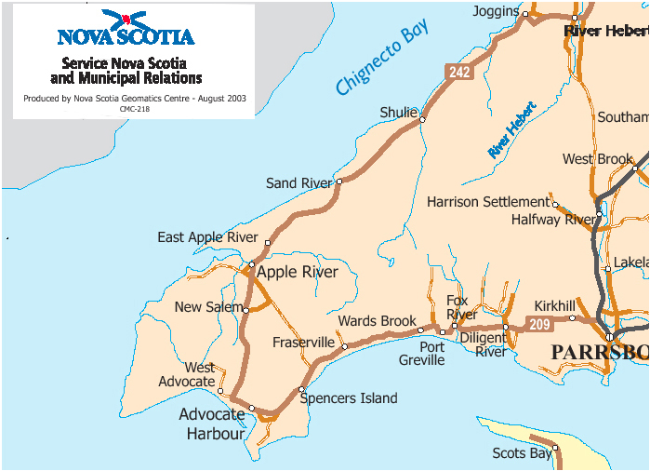

Fig.1: The Western End of Cumberland Co. on the Upper Bay of Fundy

Example One: Timber Driving Dams and Fresh Water Meadows

The 1904 Faribault-Fletcher maps have a special appeal to researchers who were teenagers in the 1950,s and who, during that time, spent many hours becoming acquainted with the forests in rural Nova Scotia. These maps bring to memory the mysterious decaying dams that were located on many of the streams and rivers flowing through the woods. The maps also remind such a researcher of fishing in what remained of large meadows where early settlers once grew hay. Faribault and Fletcher have recorded the locations of these almost forgotten sites of late nineteenth and early twentieth century activity. The dams, known as timber driving dams, were part of the lumbering industry and the meadows attracted settlers because natural grasslands provided hay that was often in short supply. Locations of timber driving dams, millsites, and meadows recorded on the GSC maps represent possible archeological sites. Because these sites are on rivers and streams they are also part of the water power/ water resources topic. A waterpower publication that may be relevant to archeology was published ca 1923 by what was then the Water Resources Branch of the Department of the Interior. The publication is a report titled the History of Water Power Legislation and Administration in Nova Scotia. This report and the list of waterpower legislation provided in an appendix warrant investigation by researchers who have an interest in finding archaeological sites located along streams and rivers. ⁶

Two former fresh water meadows, Jenks Meadow and Tipping Meadow, are marked on Fig.2. A road from Harrison Settlement to Sand River (see Fig.1) passes close to each meadow. Families no longer live on or harvest hay on these meadows and nothing remains of the former lumbering village of Sand River. Driving dams and lumber camps are shown on both Fig.2 and Fig.3. Little remains today of these once numerous sites of labour intensive activity!

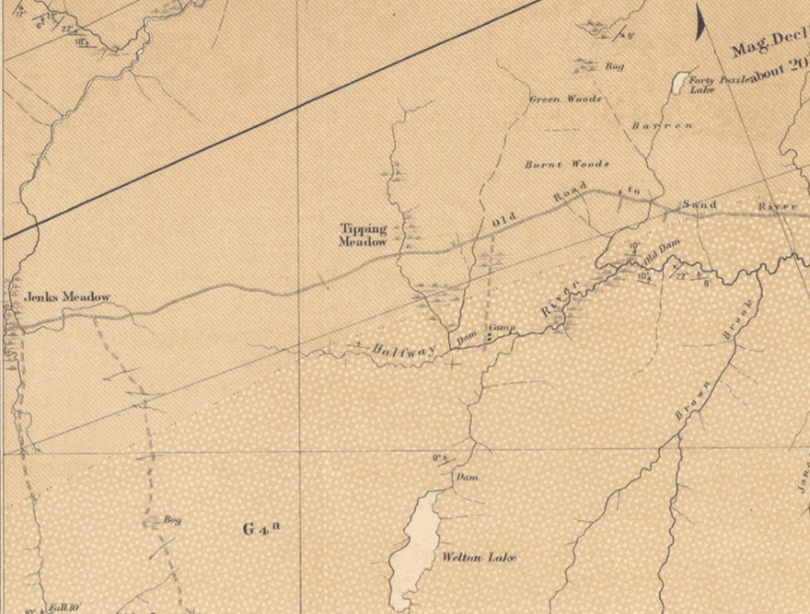

Fig.2: The Old Road to Sand River. Taken from the 1905 Faribault-Fletcher Southhampton Sheet No.82.
Reproduced with the permission of the Minister of Public Works and
Government Services Canada, 2005 and Courtesy of Natural Resources Canada,Geological Survey of Canada.

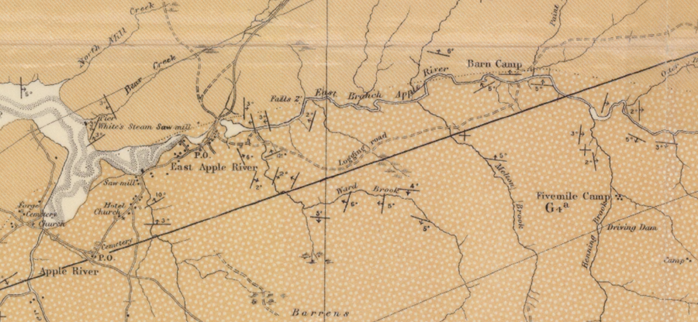

Fig.3: Timber Driving Dams and Lumber Camps. Taken from the 1904 Faribault-Fletcher Apple River Sheet No.100 and 101.
Reproduced with the permission of the Minister of Public Works and
Government Services Canada, 2005 and Courtesy of Natural Resources Canada,Geological Survey of Canada.

Example Two: Quarry at Apple River
Small communities often have stories about industries, such as small mines, shipyards, and quarries that existed in the settlement sometime in the remote past. Apple River, for example, is reported to have had a sandstone quarry that operated somewhere at the edge of the harbour. The 1904 Faribault-Fletcher multicoloured map titled Apple River Sheet No.100 & 101 provided the author with the first verification for the existence of an Apple River quarry. This map shows a grindstone quarry as well as a number of buildings located at entrance to the harbour (See Fig.4).

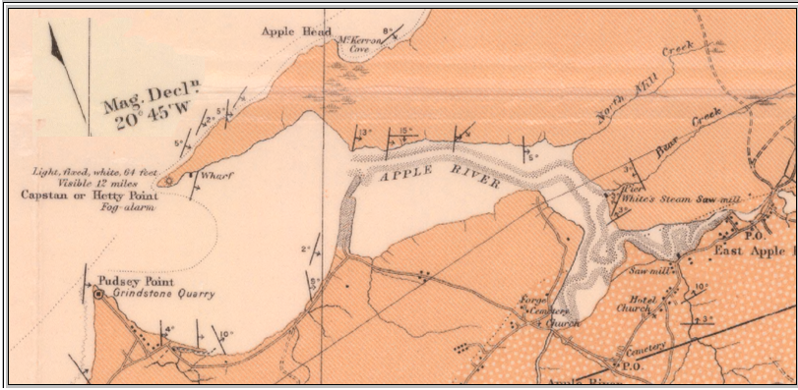

Fig.4: Apple River Harbour. Taken from the 1904 Faribault-Fletcher Apple River Sheet No.100 & 101.
Reproduced with the permission of the Minister of Public Works and
Government Services Canada, 2005 and Courtesy of Natural Resources Canada,Geological Survey of Canada.

Example Three: Establishing the Physical Location of The Village of Eatonville.

For several decades of late nineteenth and early twentieth century a small lumbering and shipbuilding community existed within the boundary of what is now Cape Chignecto Provincial Park in Cumberland Co., Nova Scotia. The community consisted of two sections: a harbour, with an entrance uniquely defined by rock formations called the Three Sisters, and a village one or two miles inland. The exact location of the village as well as its physical layout have largely passed from living memory. This is unfortunate because the location of archaeological sites that form the remains of this once thriving community are now being sought: Eatonville will soon become Cape Chignecto Park’s second entrance.

As can be seen in Fig.5, the 1904 Faribault-Fletcher Apple River Sheet clearly shows the physical layout of the two components that formed the lumbering and shipbuilding community of Eatonville; nothing much remains of this community today.

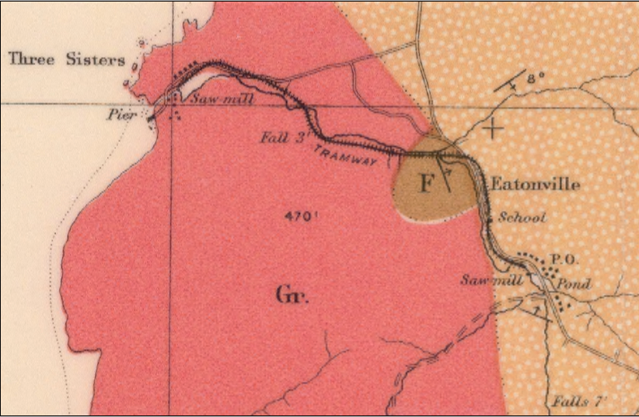

Fg.5: Eatonville. Taken from the 1904 Faribault-Fletcher Apple River Sheet No.100 & 101.
Reproduced with the permission of the Minister of Public Works and
Government Services Canada, 2005 and Courtesy of Natural Resources Canada,Geological Survey of Canada.

Appendix One: Finding Aids Giving the Name and Number Assigned to Each Multicoloured GSC Map.
Information provided by Tracy Lenfesty
Librarian, Nova Scotia Department of Natural Resources
P.O. Box 698, 1701 Hollis Street, 3rd floor
Halifax, Nova Scotia, B3J 2T9
Canada
GSC maps can be downloaded from a Natural Resources Canada on-line database. All GSC maps have a name and a number and in order to search the database the map names must be known. This appendix provides the URL for a web site containing finding aids that give the names and numbers assigned to Faribault-Fletcher Geological Maps and to Faribault Gold District Maps.
The site is
http://www.versicolor.ca/kerr/MikeParker/GSCarticle/FindingAids/

This web location contains a two page FaribaultFletcher Finding Aid and a one GoldDistrict Finding Aid. Both are reproduced with the permission of the Minister of Public Works and Government Services Canada, 2005 and Courtesy of Natural Resources Canada,Geological Survey of Canada.

The name of a GSC map sheet specifies the region of Nova Scotia displayed on the sheet. The Nova Scotia Department of Natural Resources has a web site showing the various Faribault-Fletcher regions. This Internet display is a grid superimposed on the map of Nova Scotia. Each grid rectangle is a Faribault-Fletcher region and the GSC map number appears at the center of the rectangle. The GSC map name associated with each rectangle can be determined from the Faribault-Fletcher finding aid mentioned in the last paragraph. The URL for the Nova Scotia Department of Natural Resources web site is
http://www.gov.ns.ca/natr/library/ffindex.htm
Appendix Two: The Earth Sciences Information Centre On-line Data Base and the Procedure for Downloading GSC Maps
Digital copies of the Faribault-Fletcher Geological Maps as well as the Faribault Gold District Maps can be obtained free of charge from a data base on a web site operated by Natural Resources Canada. This site, called The Earth Sciences Information Centre, and the data base, titled "GEOSCAN Database", is accessed at
http://ess.nrcan.gc.ca/esic/geoscan_e.php

The maps in the GEOSCAN Database can be downloaded as PDF or as MrSid files. MrSid files are opened by using a free program called MrSid viewer. The Library of Congress and other institutions, such as Natural Resources Canada, use a version of MrSiD to create compressed files for the Internet. A copy of the MrSid viewer can be downloaded from the web site http://www.lizardtech.com/download/

The procedure for searching the GEOSCAN Database is given at http://www.johnabbott.qc.ca/webpages/departments/physics/kerr/new/GSC/Two

End Notes

¹ Geological Survey of Canada, Annual Report, ( New Series), Volume V, Part II, ( 1890-91) Part P, “Report of the Geological Surveys and Explorations in the Counties of Pictou and Colchester”, Nova Scotia , by Hugh Fletcher, p. 168 P

This report was submitted to the Director of the GSC, Alfred R. C.. Selwin , by Hugh Fletcher. The report describes the work done by Hugh Fletcher during the summers of 1887 to 1891 in the counties of Pictou, Colchester, Hantz, and Cumberland.

² Morris Zaslow , Reading the Rocks: The Story of the Geological Survey of Canada 1842-1972, the Macmillan Company of Canada, Ottawa, 1975, Chapter 1.

This 600 page book, written by a University of Western Ontario history professor, is an excellent source of information on the Geological Survey of Canada. At the end of this very detailed book, the author provides an excellent and useful “Essay on Sources”

³ Ibid., pp. 3-4

⁴ Ibid., pp. 180-181

⁵ Ibid., p. 118, pp 180-181,
The Nova Scotia Museum web site has a short biography for both Fletcher and Faribault
http://museum.gov.ns.ca/fossils/finders/fletcher.htm

⁶ Library and Archives Canada, Report # 684, A History of Water Power
Legislation and Administration in Nova Scotia, Department of the
Interior, Water Resources Branch, RG 89, Volume 528 .

