Geology and Land Grants

The major geological formations along the Road to Cumberland may have influenced a wide range of human activities, including the way in which the early settlers worked and traveled in that region. These formations were both beneficial and a source of problems. They enabled the settlers who lived along the Road to work at agriculture and lumbering and settlers living in the coastal area were involved in fishing, shipbuilding, and seafaring as well as farming and lumbering. The problems were seasonal flooding of the fertile low lands along the road and erosion at certain coastal regions such as the site of the Ottawa House. The influence that landscape formations have on human activities is a broad subject and will only be briefly mentioned. The influence of geological formations on the placement of land grants will be emphasized.

When the governor of Nova Scotia and his council granted land in a particular region of the province they issued a “warrant to survey” to the provincial Surveyor General. The Surveyor General, or one of the deputies, was then responsible for deciding the specific location and boundaries of the grant or grants to be issued when the survey work was completed. On the Road to Cumberland the governor issued grants over a period of time but only a few grants were issued along the northern portion of the road. These tended to be very large lots of land granted to prominent individuals. Examples include the 8000 acres at Minudie granted to J.F.W. DesBarres in 1765 and 20000 acres on the River Hebert given to Michael Francklin(Crown Land Information Management Centre,1765) in 1765. Joseph Frederick Wallet DesBarres was an army engineer and surveyor; Michael Francklin was a Halifax merchant who became lieutenant governor of Nova Scotia in 1766.

Along the southern section of the Road to Cumberland the provincial surveyors laid out many long narrow strips of land with each strip being a possible grant; some settlers received more than one strip. This section of the route is of particular interest to the history of the settlement at Partridge Island and to the later settlements that formed along the road from Partridge Island to Pettigrew Settlement. It is this southern section of the route that will be the major focus of this paper. The remainder of the route will be only briefly mentioned.

A traveler approaching Partridge Island from the water would see a natural coastal formation created by a series of complex processes at the end of the last Ice-Age (Donald J. P Swift and Harold W. Borns, Jr., 1967 and Atlantic Geoscience Society 2001, Chapter 9). This formation, extending from Advocate to Five Islands (see Fig.7) and composed of silt, sand, gravel, and boulders, is called a “raised outwash terrace”. At Partridge Island the Chignecto River eventually cut through the terrace to form an estuary (present day Parrsboro Harbour). The north-south orientation of this estuary was selected by a provincial land surveyor to be the dividing line between what are believed to be the first two land grants in this part of the Minas Basin. The ferry would have landed on the beach in front of one of these grants.

At the end of the 1760’s, the flat top of the terrace in the Partridge Island region and on the western side of the estuary must have caught the attention of provincial deputy land surveyor Josiah Troop. At the end of this decade Troop and several other provincial surveyors laid out two large tracts of land known as the Partridge Island Grant and the Philadelphia Township Grant. The 2000 acre Partridge Island Grant was located on the western side of the estuary and the 20000 acre Philadelphia Township Grant, issued in 1767 to Nathan Shepherd and nineteen others from the City of Philadelphia, began on the eastern side of the harbour and extended eastward along the coast to Five Islands (Crown Land Information Management Centre. 1767).

The Partridge Island Grant was issued in 1776 to John Avery, Jacob Bacon and John Lockhart with the proviso that they run a ferry. However, Troop’s drawing (Fig. 8) for this grant is dated 10th March 1767 (1769?) and is divided into town lots and field lots. This complexity is not what one would expect a surveyor to lay out for three men operating a ferry! Josiah Troop’s plan for the Philadelphia Township Grant, located in an archival collection at the Pennsylvania Historical Society, is dated at Partridge Island on September 14, 1767 (Wright, 1977, p.117-118). The dates on these two surveyor’s maps lead one to wonder if the land laid out on the raised terrace at present day Parrsboro was initially intended for a group other than Avery, Bacon and Lockhart?

Fig.8 shows the position of the Partridge Island Grant on the Road to Cumberland and Fig. 9 (Crown Land Information Management Centre, 1767 (1769?)) is the 1767 (1769?) surveyor’s drawing for this grant. The long narrow strips of land on this plan front on the Chignecto River and are probably so-called “town lots”. Most or all of these lots are on the raised outwash terrace. At Partridge Island the portion of the raised terrace on which the Ottawa House sits faces the open Minas Basin and is therefore is subject to erosion during stormy weather.

To date a copy of the surveyor’s drawing for the Philadelphia Township Grant has not been located; however, the grant issued for the Philadelphia Township does describe the boundaries of the Township. As with most grants, the Philadelphia Township was issued with conditions that had to be met within a defined time period, otherwise the land reverted back to the Crown by a legal process called escheatment. On March 9, 1784 the Commissioner of Escheats, Richard Bulkeley , and twelve jurors made the decision to escheat the Philadelphia Township Grant (Crown Land Information Management Centre, Escheat No 66). Two exceptions, involving the settlers Steven Harrington and Jacob Walton, were written into the escheat document. Harrington and Walton had acquired land in the Township and because they had made improvements that fulfilled the grant conditions their properties were not included in the escheat.

Moving inland a short distance the Road to Cumberland begins to pass through the Cobequid Highlands (The Last Billion Years, p. 67) by way of the “Parrsboro Gap” (Stea, Finch, and Wightman, 1986,p.6). On leaving this Pass, one encounters Gilbert Lake, the headwater for River Hebert, and Devil’s Lake, the headwater for the Chignecto River; these two lakes are separated by the recessional moraine described earlier. In the time of travel by canoe this ridge of glacial till, indicated by “Carrying Place” on Fig.2 and Fig.3, was a portage between the north flowing River Hebert and the south flowing River Chignecto.

From Gilbert Lake, the Road to Cumberland lies on the so-called Cumberland-Pictou Lowlands (Stea, Finch, and Wightman, 1986, Fig.1, p.3). As described in the previous section, it is on these lowlands that Robinson and Rispin observed the interval land and meadows (See Fig.5). Just north of Newville Lake and moving down the River Hebert the Road moves past Pettigrew Settlement and onto the “Boars Back”, a long ridge of glacial till called an esker (Stea, Finch, and Wightman, 1986,p.25). The overland trail portion of the Road to Cumberland went along the top of this ridge and the waterway portion was the River Hebert, which flows close to and adjacent to the “Boars Back” esker.

The start of the “Boars Back” esker is the approximate divide between two land grant patterns on the Road to Cumberland. This divide is also the boundary line that existed between Kings County and Cumberland County from 16 Dec. 1785, when the Governor and Council changed the boundaries of Kings County, until 1840 (Fergusion, 1966, p.43). On the north of the boundary one finds the 8000 acres at Minudie to J.F.W. DesBarres in 1765 and 20000 acres on the River Hebert to Michael Francklin in 1765. The process by which these two grants were eventually subdivided and placed in the hands of others is a separate topic that needs to be thoroughly researched.
Fig.10 shows the surveyor’s map for the portion of the Road to Cumberland that lies south of the dividing line (Library and Archives Canada). The date of this Charles Morris map is uncertain, the date at the top appears to be 1774 or 1784. Notice that this grant begins on the east side of the estuary at the mouth of the Chignecto River and has one branch of 33 divisions that are laid out along the coast as far as Five Islands. 1784 is a possibility because 1784 is the year that the Philadelphia Township Grant was escheated. The 33 lots along the bottom of Fig 10 represent a redrawing of the 20 Philadelphia Township Grant lots that are mentioned in the 1767grant that was issued for the Philadelphia Township.

Notice that the front of each lot on Fig.10 borders on the water. This was essential in the days when water was an important means of transportation. An effort appears to have been made to place the lots in the valley formed in the Cobequid Highlands by the Parrsboro Pass and that north of the Cobequid Highlands the lots are along the valley formed by the river Hebert. The land surveyors who were given the task of laying out grants for settlers must have had an eye for taking advantage of landscape geology.

As mentioned earlier the geological formations on the Road to Cumberland were formed by a series of complex processes at the end of the last Ice Age. This sequence of events is called postglacial geology, one of the many sub-fields of geology. The bedrock beneath the Road to Cumberland’s glacial formed landscape is also interesting but is however, beyond the scope of this paper. Material on the bedrock geology can be found in the publication “The Last Billion Years”.

One more landscape feature of this overland travel route needs to be described. This is a tidal estuary formed approximately the last 6300 years (Amos, 1978, P 965-981) at the mouth of each of the route’s two rivers. The salt marshes on the upper reaches of these estuaries were a source of salt marsh hay for both the Acadian and the English settlers. The salt marshes on both sides of the River Hebert were dyked but evidence of dyking at Parrsboro has not been located. Unlike the mouth of the River Hebert a barrier beach (spit) protects the mouth of the Chignecto River and when the tide is in, the lagoon that forms behind this coastal barrier provides Parrsboro with a deepwater harbour.

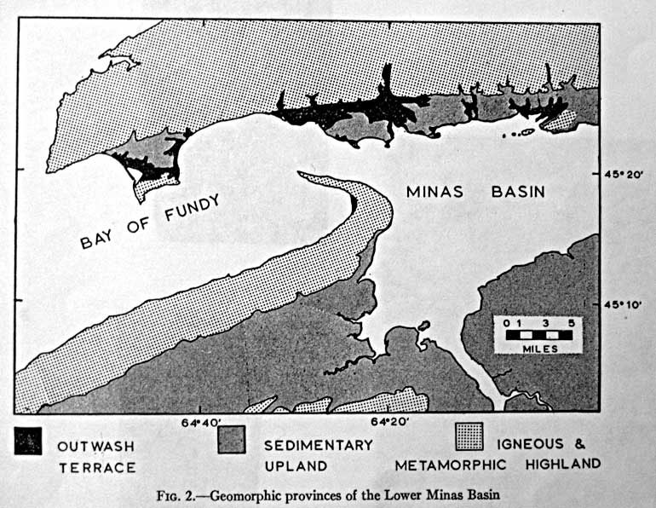

Fig.7: Taken from the article “A Raised Fluviomarine Outwash Terrace, North Shore of the Minas Basin, Nova Scotia”, by Donald J. P Swift and Harold W. Borns, Jr., Journal of Geology, V 75, 1967, p 693

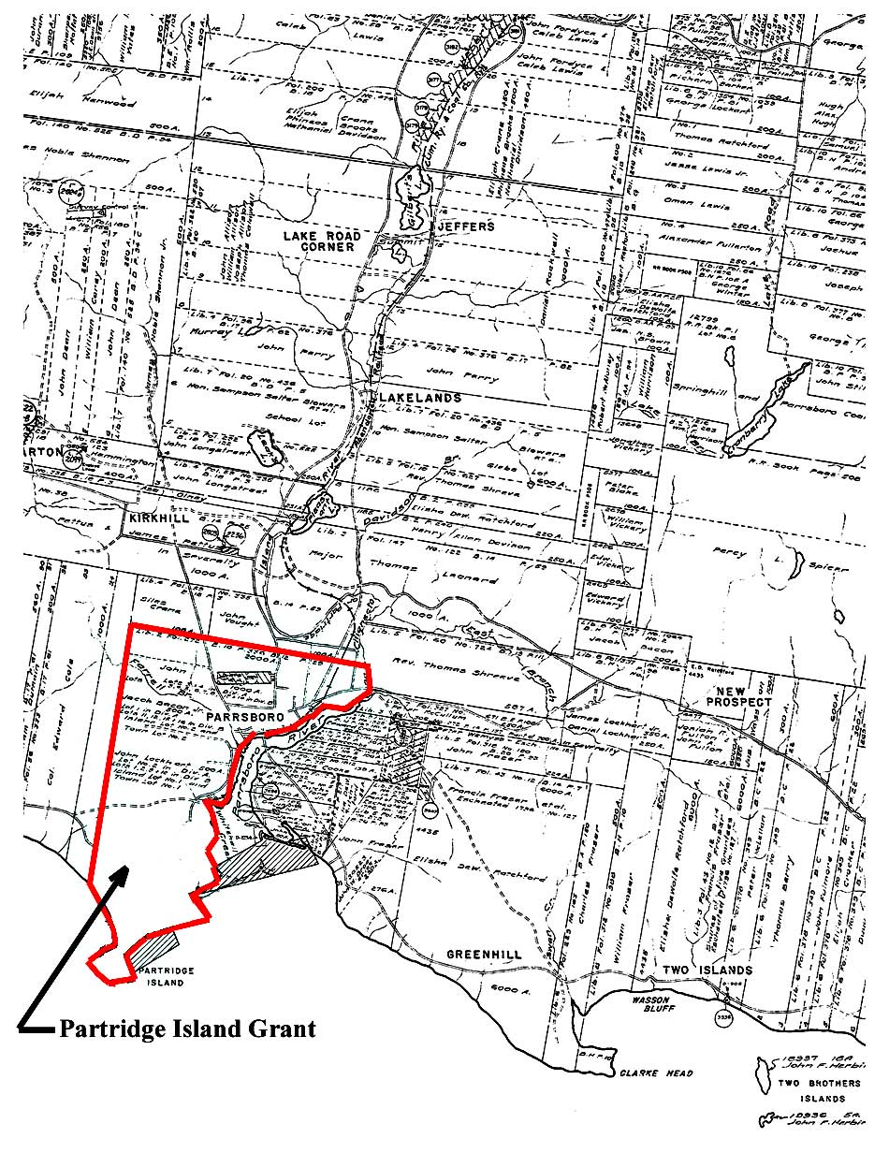

Fig 8. Position of the Partridge Island Grant on the Road to Cumberland. Taken from Land Grant Index Sheet No 51 http://www.gov.ns.ca/natr/land/grantmap.asp

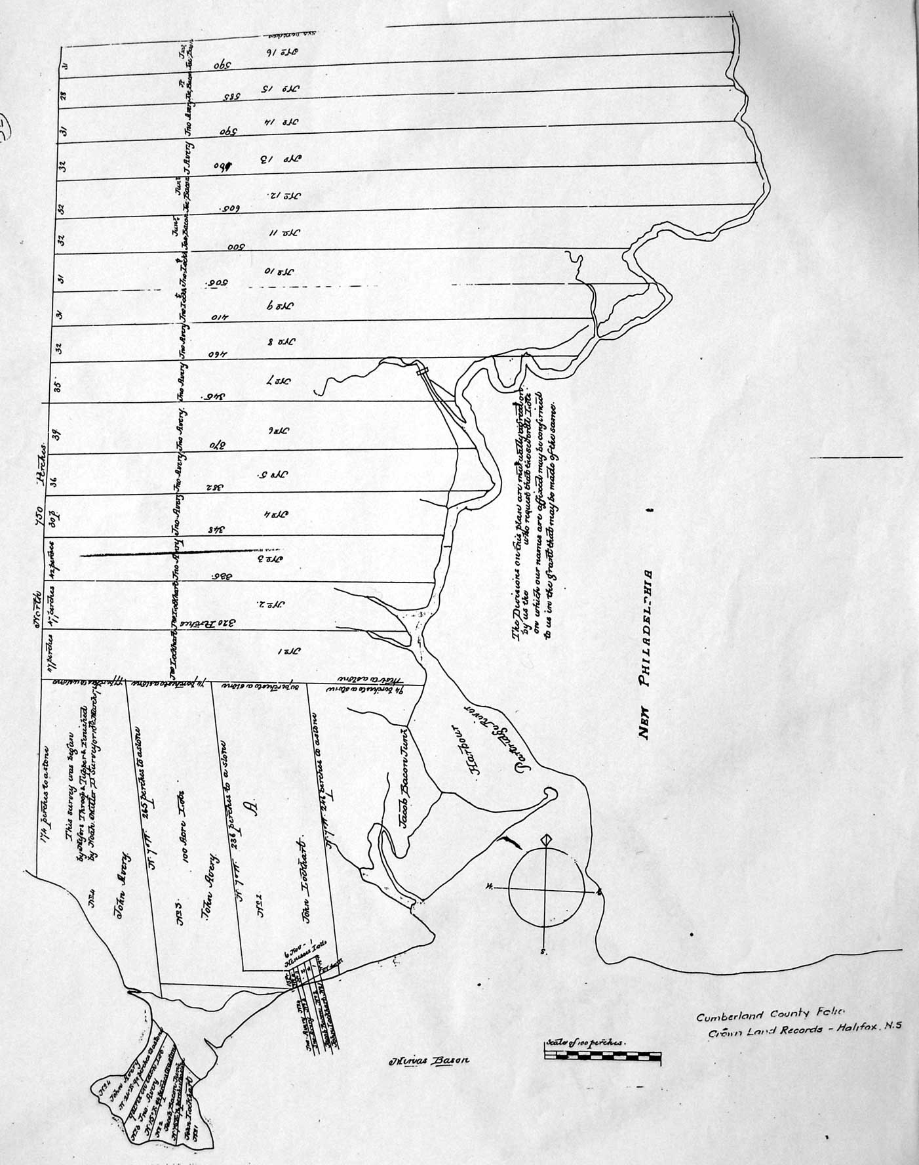

Fig. 9: 1767 (1769?) Surveyor’s Drawing for the Partridge Island Grant. Cumberland County Portfolio, Crown Land Information Management Centre. Dept. of Natural Resources, Halifax, NS

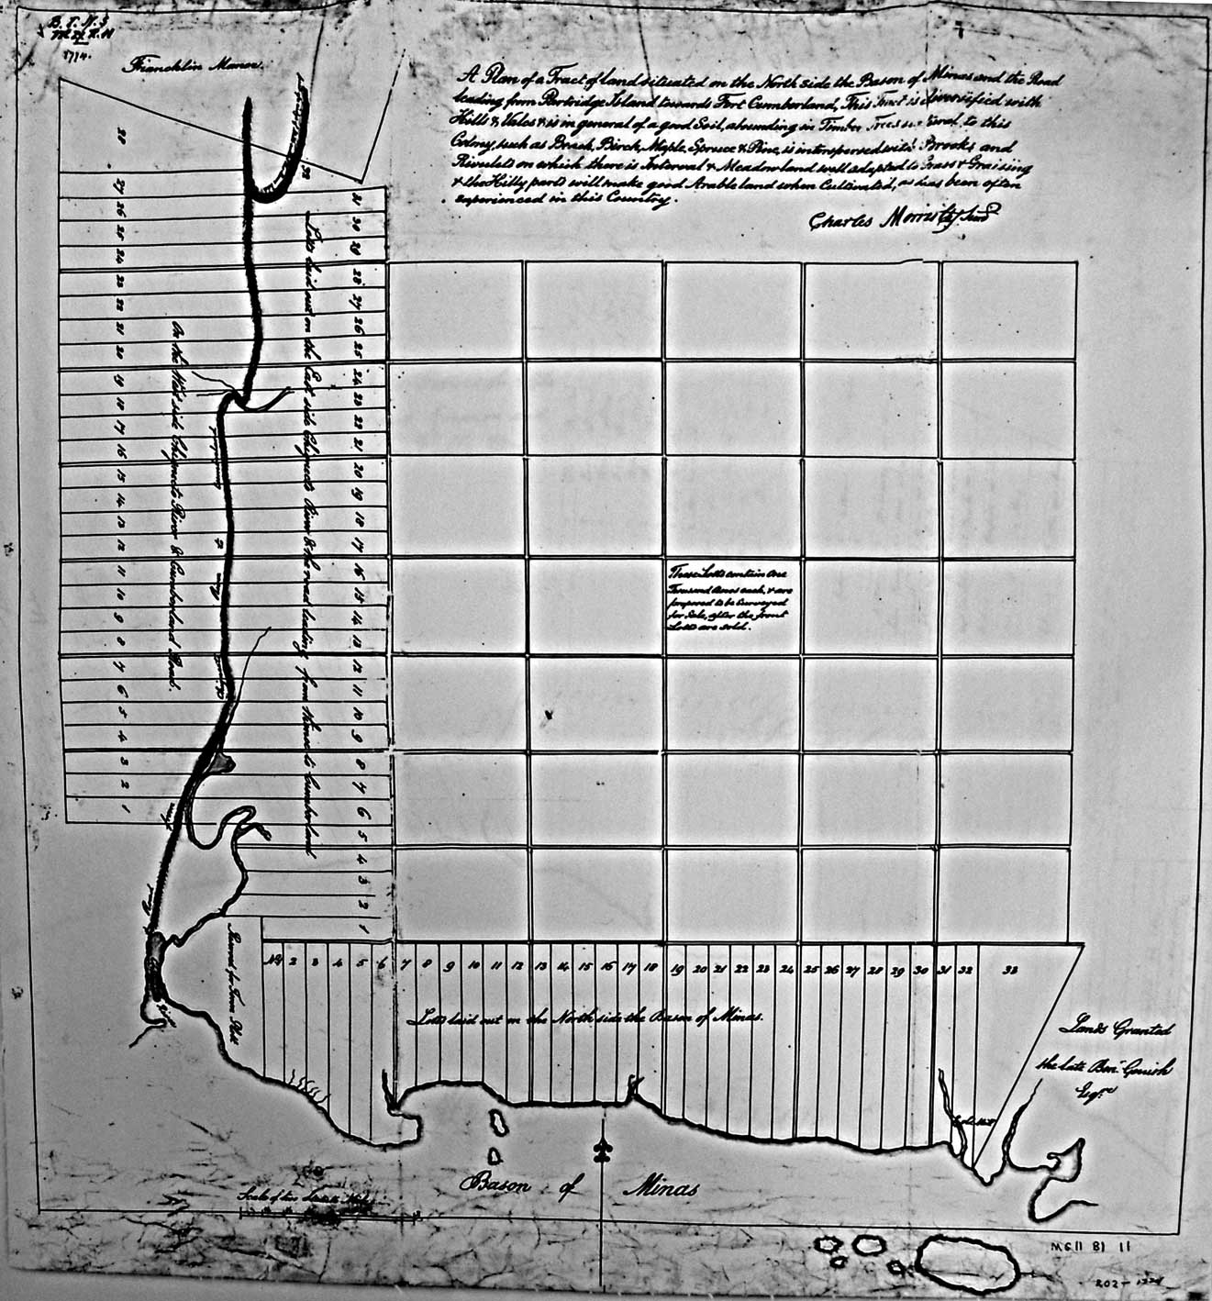

Fig. 10: Grant lots on the Road to Cumberland from the Mouth of the Chignecto River to Francklin’s Manor. Maps, Plan and Charts, H2/220/Cumberland/1774 No. 519, Library and Archives Canada, Ottawa, Ont.

Appendix A: The Tobigan

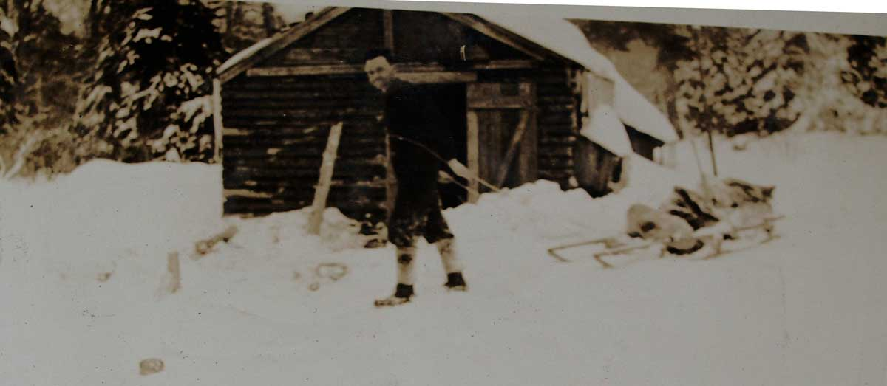
Fig A1: James MacDougall and his tobigan at an overnight camp on the snow blocked Eatonville Road. Circa 1920’s or 1930’s.

While growing up in Parrsboro during the 1940’s and 1950’s, I often accompanied my father on trips to our “timberland” located five miles north of Port Greville. The trips were made to cut fire wood, logs, and long “timbers” that my father used in the Canning Family business that involved moving houses (Parker 2009,p.159). It was often necessary to spend several days in a small camp on the property. During the winter several miles of the narrow woods road to our property were unplowed and supplies were hauled to the camp on a special sled called a tobigan (pronounced toby-gun). The runners for the sled were as wide as skis and all parts of the sled were fastened together by wooden pins. My father said that tobigans were handmade and that most woodlot owners used them at onetime. He also thought that they were originally designed and made by the Mi’kmaq.

With the exception of a few surviving men and women who were involved in traditional lumber practices, the tobigan is all but forgotten. This is unfortunate since it had an elegant and artistic appearance; it was very functional with a clever design. A few pages are devoted to the tobigan in the publication Older Ways: Traditional Nova Scotia Craftsmen (Barss,1980).

On my behalf, Gerald Gloade, Program Development Officer for Mi'kmaq Museums and Cultural Centres, asked the Mikmawey Debert Elders Advisory Council if they thought that the tobigan was used by the Mi’kmaq prior to contact with Europeans. The Council’s reply is given below.

Question:
Toboggan = contemporary, Mi’kmaq French/Mi’kmaq English ???
Tobigan, pronounced toby-gun = Sled type with runners ???

“Our Elders feel that the word “Tobigan” is actually the Mi’kmaw word “Po’qikn”. “Po’qikn” meaning “Hole Maker” referring to the drilled and doweled side walls. The Elders said it is of Mi’kmaq origin and we had them
before European contact. And that they were used for furs and supplies”.

1) The Mi’kmaw language is a verb based language. Very detailed in the descriptive meanings of form and function.

Mi’kmaq:
“Toboggan” = Tapaqn, meaning, “to pull or drag along the ground.”
“Sled” = Tapaqanji’j, “ji’j” means “Small”
“Sleigh” = Waqa’sskiaq, tapan
“Slippers” = poqqane’jk, “ji’k” means ”Little”

2) Mi’kmaw Elder Dr. Murdena Marshall, Eskasoni First Nation,
Cape Breton County Nova Scotia (902) 379-2508 said she has 2 of them
at home.

Figures A1, and A2 show a tobigan being used in the 1930’s to haul camp supplies from Advocate to a lumber camp at Eatonville. This two-day over night trip into the camp took place every week because the seven-mile road from Advocate to Eatonville was not plowed during the winter.

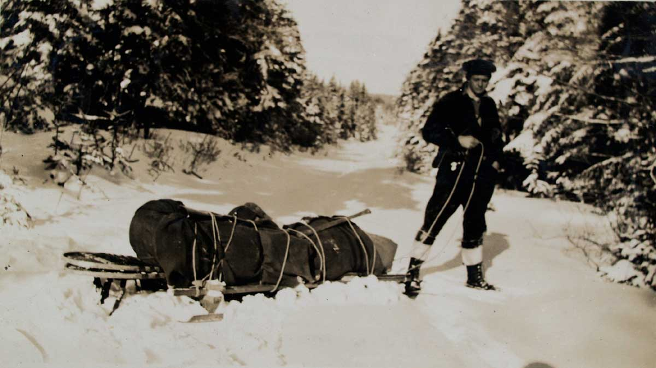

Fig A2: James MacDougall and his tobigan on the snow blocked Eatonville Road. Circa 1920’s or 1930’s.

Appendix B
Accounts by Travelers Who Used the Route to Cumberland

Several first person accounts by travelers who used the Road to Cumberland in the eighteenth century have survived. These documents are not always easy to read because they are written in the language of 1700’s. First person accounts are, however, valuable records and if one persists when the language seems strange, interesting historical insights can be gleaned from the documents. This section will give excerpts from two such pieces of writing.

The first item is a letter written in 1791 by the Rev. Hugh Graham of Cornwallis to the Rev. Andrew Brown, D.D. who wishes to visit Cumberland (Graham,1791). Hugh Graham has traveled the Road to Cumberland in the past and he wishes to tell Brown about what to expect while traveling along the road and at the same time a few road related stories. One of Rev. Graham’s stories involves a disturbing encounter between solders and a group of Acadians. Graham’s letter requires perseverance but the rewards make it worthwhile.

The second item is taken from the diary of Henry Alline, a self-taught evangelical preacher from Horton Township (Alline, 1806). In 1781 Alline crosses the Minas Basin and uses the Road to Cumberland to reach several communities north of Amherst. Henry Alline encounters privateers at Partridge Island.

A 1791 letter from the Rev. Hugh Graham
The Nova Scotia Archives and Records Management has a web page displaying material from the Andrew Brown Collection. This material, titled Collections of the Nova Scotia Historical Society, Vol. II (1881); pp. 129-160, contains several transcribed letters written to The Rev. Andrew Brown, D.D. One of these letters, dated 1791, contains detailed information on the "Road to Cumberland". The letter is from the Rev. Hugh Graham of Cornwallis and was written partially to give instructions to Rev. Brown who was planning a trip to Cumberland. Rev. Graham’s letter starts on page 135 but it is not until five pages later, on page 140, that a description of the "Road to Cumberland" can be found.

Rev. Hugh Graham’s description of the "Road to Cumberland" is given below. In his description Rev. Graham digresses twice to tell a story. These informative stories have been removed and placed at the end of this section on Rev. Hugh Graham.

“I understand that you purpose visiting Cumberland this summer, the scene of Watson's youthful years-for he was only between 10 and 12 years of age when he came under Capt. Huston's patronage and lived just about so many in his family. As I have a transient view of that part of the Province, I shall take the liberty of just mentioning a few objects that will naturally engage your attention, excite your enquiries, and more especially as you asked some time ago the notice of my Cumberland tour.
After leaving Partridge Island 17 miles in the rear, for I presume you will travel by land, you will mount what is properly called the Boar's Back, a narrow ridge of land 7 miles in length, and in a few places more than 20 rods in breadth. It stands between a continued narrow swamp on the south-west side, and between swamps, lakes and a river on the north-east side. It is of no great height. It seems to be an entire bed of gravel, and serves as an excellent road. In this instance, as in many others, the hand of nature hath saved man a hard task. Quitting the Boar's Back you will soon reach the head of the river of Herbert Bear. This takes its rise in the lakes on the north-east side of the Boar's Back. It begins to flow by the upper hump and runs about due west. The tide also makes up to the head of the river, so that the Boar may alternately drink salt water and fresh in the course of every day…………… (digresses to tell a story: Story One)……………………………………..
Excuse this digression. My zeal to be of some service to you makes me write several things which, upon reflection, I am apt to think can be of little or no service. At the head of Bear River you will find one solitary house of entertainment. It may afford some pleasure after you have rode 8 miles without having seen the habitation of man, and when you take into the view that you must ride 10 miles before you come to another. Here you ride along a continued strait of marsh land, about a mile beyond the first house you now pass, occupied by a Lieut. McKecachran, from Isla, lives, Mr. Glenie, brother to Capt. Glenie, late of the artillery department. The captain studied divinity in Edinburgh Hall, and is said to be a gentleman of very shining abilities. Perhaps you know the character. At the rate L1500 he bought that large tract of land lying in 12 miles square on both sides of Bear River, and extending from the head of ye river to the foregoing place. His brother has the charge and management of his improvements. You will find him a sensible, frank, and open-hearted farmer, who will be exceedingly glad to entertain you at his house, and will make you very happy. Below his house, more than a mile, there is a French settlement called Men eu die (Meneudie). In this village there is between 20 and 30 houses and a chapel. There you will find a fragment of the stile and manners of other times, after this you will cross the river in a log canoe, or rather in Glenie's boat upon which you enter the township of Amherst………( digresses to tell another story:Story Two)…………………………… After leaving Amherst the remains of Fort Lawrence by the roadside will attract your attention for a short space. From that you will pass on to Fort Cumberland”.
Rev. Hugh Graham’s digression Story One

“The tide also makes up to the head of the river, so that the Boar may alternately drink salt water and fresh in the course of every day; a branch of this river called Napana was the scene of one of those barbarous outrages which created a distant likeness between Scotia junior and Scotia senior. A party of rangers of a regiment chiefly employed in scouring the country of the deluded French who had unfortunately fallen under the bann of British policy, came upon 4 Frenchmen who had all possible caution, ventured out from their skulking retreats to pick some of the straggling cattle or hidden treasure, The solitary few, the pitiable four, had just sat down weary and faint on the banks of the desert stream in order to refresh themselves with some food and rest, when the party of Rangers surprised and apprehended them, and as there was a bounty on Indian scalps, a blot, too, on England's escutcheon, the soldiers soon made the supplicating signal, the officer's turned their backs, and the French were instantly shot and scalped. A party of the Rangers brought in one day 25 scalps, pretending that they were Indian's, and the commanding officer at the fort, then Col. Wilmot, afterwards Governor Wilmot (a poor tool) gave orders that the bounty should be paid them. Capt. Huston who had at that time the charge of the military chest, objected such proceedings both in the letter and spirit of them. The Colonel told him, that according to law the French were all out of the French; that the bounty on Indian scalps was according to Law, and, that tho' the Law might in some instances be strained a little, yet there was a necessity for winking at such things.Upon account Huston, in obedience to orders, paid down L250, telling them that the curse of God should ever attend such guilty deeds. A considerable large body of the French were one time surprised by a party of the Rangers on Peticodiac River; upon the first alarm most of them threw themselves into the river and swam across, and by ways the greater part of them made out to elude the clutches of these bloody hounds, tho' some of them were shot by the merciless soldiery in the river. It was observed that these Rangers, almost without exception, closed their days in wretchedness, and particularly a Capt. Danks, who even rode to the extreme of his commission in every barbarous proceeding. In the Cumberland insurrection (late war) he was suspected of being Jack on both sides of the bush; left that place, Cumberland, in a small jigger bound for Windsor, was taken ill on the passage, thrown down into the hold among the ballast, was taken out at Windsor, is half dead, and had little better than the burial of a dog. He lived under a general dislike and died without any to regret his death. Excuse this digression. My zeal to be of some service to you makes me write several things which, upon reflection, I am apt to think can be of little or no service.”

Rev. Hugh Graham’s digression Story Two

The 2nd house on your way is occupied by one emphatically called Forrest, the rich man. It will not be amiss to give him a call. He is a curiosity. He is the unpolished rustic; has, however, a large share of natural sense blended with a very gross vein of drollery. He is one of a small congregation of Irish Pbns. who will gladly and gratefully attend on your salutory instructions on the sacred day when the call is Let us go up to the House of the Lord. There is among them a Mr. McGowan, an elder, a worthy and agreeable man. They have built a decent little meeting-house, have made several attempts to get a minister, and after repeated disappointments, it is said one will be sent them from Scotland this summer — one of Mr. McGregor's class. But if he does come I fear it will be too late to do much good, or to live with any manner of comfort in that place. There are not now above a dozen of professed Pbn. families in the whole settlement. After leaving Amherst the remains of Fort Lawrence by the roadside will attract your attention for a short space. From that you will pass on to Fort Cumberland.”

Henry Alline: The traveling preacher from Horton Township

Henry Alline, 1748 – 1784 and his parents were New England Planters who settled in Horton Township in 1760. From 1776 until his death in 1784 Henry Alline was an independent and self-taught evangelical preacher who traveled to various parts of Nova Scotia giving sermons in barns and people’s homes. His published diary contains brief notes that provide a small but significant amount of information on the “Road to Cumberland” and on Partridge Island. They confirm, for example, that some travelers did cross over the mouth of the River Hebert to Amherst Point. As well, Henry Alline’s diary confirms that enemy privateers did visit Partridge Island during the American Revolution. Excerpts relevant to this paper will now be presented.

On August 7, 1781 Henry Alline was in Windsor waiting for a vessel to take him to Partridge Island. His diary entry reads:

“The vessel that I had been waiting for to go to the county of Cumberland was now in. I went on board her, and the same day we sailed, after I had bid my friends a farewell, promising to return to them as soon as possible. We lay in the Basin of Minas all that night. About midnight there was a terrible thunderstorm, but the Lord was kind to me, blessed be his name for it”.

The next day he wrote:

“On Sabbath Day I got to Partridge Island and preached there about seven in the morning to what people were there. They were about 20 in number, and seemed to give great attention to the word preached, and my own soul was blessed. And great, yea great was God’s goodness to me. O that I could love him with all my soul”!

On Aug.9 1781 Henry Alline must have left Partridge Island alone on horseback and followed the “Road to Cumberland” because his diary entry states that “ I rode through the woods about 50 miles to where it was inhabited. I was in a strange place, where I never had been before: but O the Lord remembered his poor unworthy servant, and gave me many blessed moments when riding alone”.
Presumably Alline arrived somewhere between the present-day communities of River Hebert and Minudie because after preaching on the 10th of August he wrote in his diary the next day “I crossed the River to Amherst Point, and preached there in the evening”.

After reaching Amherst Point Henry Alline traveled to various settlements in the Amherst, Sackville, and Petit Codiack River regions of 1781 Cumberland County; New Brunswick would not be established until August 16, 1784. After preaching at these communities Alline returned to the Amherst area and on Sept. 20, 1781 he wrote in his diary “Road about 10 miles and crossed the river”. His diary entry for the next day reads; “I then rode to Partridge Island”.

Henry Alline was still in Partridge Island on the morning of Sept. 22, 1781 and his diary entry for that day is very significant for Partridge Island history. The diary reads:

“Sept. 22, 1781: This morning about break of day I was called out of my bed, and carried onboard a privateer, but not out of any ill will to me, only they found, there was such a man there with a horse, and they, intending to take some vessels from out of the basin, were afraid that I should carry back intelligence to Cumberland before they had got ready to sail from that harbour. When I came on board, the captain told me I should suffer no injury, but have whatever I wanted, and be put ashore again as soon as they had taken three prizes. Let them that wish well to their soils flee from privateers as they would from the jaws of hell, for methinks a privateer may be called a floating hell”.

Alline ‘s experience onboard the privateer must not have been too traumatic because on Sept. 23, 1781 he wrote “I enjoyed this day some happy moments at my pen and likewise in my private walks about the island. I much acknowledge, the kindness of God to me is great”.

The next day Henry Alline left Partridge Island. His entry states “I was this day in an open boat put across the basin to Horton, and left my horse behind me on Partridge Island, the ferry boat not being there”.

The Road to Cumberland has many stories that have long ago passed out of memory and were never recorded for posterity. Some, like the two given above, have been preserved and hopefully more will surface in the future.

References

Atlantic Geoscience Society 2001. The Last Billion Years , A Geological History of the Maritime Provinces of Canada , . Halifax, Nova Scotia,
: Nimbus Publishing Ltd

Barss, Peter. 1980. Older Ways:Traditional Nova Scotia Craftsmen. Toronto: Van Nostrand RVan Nostrand Reinhold Ltd.

Campbell, Gary. 2005. The Road to Canada: The Grand Communications Route from Saint John to Quebec ,New Brunswick Military Heritage Series 5. Fredericton, New Brunswick: Goose Lane Editions:New Brunswick Military Heritage Project.

Conrad, Margaret, ed. 1988. They Planted Well: New England Planters in Maritime Canada. Fredericton, New Brunswick: Acadiensis Press.

Crown Land Information Management Centre. Dept. of Natural Resources, Halifax, NS.,. 1765. Book 006, page 329, and Book 006, page 716.

Crown Land Information Management Centre. Dept. of Natural Resources, Halifax, NS.,. 1767. Grant Book 006, page 703 and Grant Book 007, page 238.

Crown Land Information Management Centre. Dept. of Natural Resources, Halifax, NS.,. 1784. Escheat  No 66.

Crown Land Information Management Centre. Dept. of Natural Resources, Halifax, NS.,. 1767 (1769?). Cumberland County Portfolio.

Dawson, Joan. 1988. The Mapmaker’s Eye, Nova Scotia Through Early Maps, . Halifax: Co-published by Nimbus Publishing Limited and The Nova Scotia Museum, .

Deveau, Sally Ross and J. Alphonse. 1992. The Acadians of Nova Scotia Past and Present. Halifax, Nova Scotia: Nimbus Publishing Ltd.

DeWolfe, Barbara. 1997. Discoveries of America : personal accounts of British emigrants to North America during the revolutionary era. New York Cambridge University Press.

DeWolfe, Barbara. Discoveries of America : personal accounts of British emigrants to North America during the revolutionary era. Cambridge University Press 1997 [cited February 15, 2010. Available from http://www.cambridge.org/uk/catalogue/catalogue.asp?isbn=9780521385428.

Donald J. P Swift and Harold W. Borns, Jr. 1967. A Raised Fluviomarine Outwash Terrace, North Shore of the Minas Basin, Nova Scotia. Journal of Geology V 75.

Fergusson, Charles Bruce. 1966. The Boundaries of Nova Scotia and its Counties:Bulletin of the Public Archives of Nova Scotia, No22. Halifax: Public Archives of Nova Scotia.

Graham, Hugh. Acadian French: Letter from Rev. Hugh Graham to Rev. Brown 1791 [cited Febuary 13, 2010. Available from http://www.gov.ns.ca/nsarm/virtual/deportation/archives.asp?Number=NSHSII&Page=129&Language=English.

Murphy, J. M. 1976. The Londonderry Heirs: A Story of the Settlement of the Cobequed Townships of Truro, Onslow, and Londonderry, in Nova Scotia, Canada, by English-Speaking People in the Period 1760 to 1765. Middleton, Nova Scotia: Black Printing Co. Ltd.

Parker, Mike. 2009. Gold Rush Goast Towns of Nova Scotia. East Lawrencetown, Nova Scotia: Pottersfield Press.

Rispin, Charlie. Thomas Rispin Farmer of Fangfoss East Yorkshire 2000 [cited February 12, 2010. Available from http://www.rispin.co.uk/farmer.html.

Stea, R. R., P. W. Finch, and D. M. Wightman. 1986. Quaternary Geology and Till Geochemistry of the Western Part of Cumberland County, Nova Scotia (Sheet 9). In Geological Survey of Canada, Paper 85-17

Wright, Esther Clark. Cumberland Township: A Focal Point of Early. Settlement on the Bay of Fundy 1946 [cited February 12, 2010. Available from http://atlanticportal.hil.unb.ca:8000/archive/00000091/01/wright.pdf.

Wright, Esther Clark. 1977. Blomidon Rose. Wolfville, Nova Scotia.

Library and Archives Canada, Ottawa, Ont., Maps, Plan and Charts, H2/220/Cumberland/1774 No. 519,

