The Road to Cumberland: An early travel route that shaped history

This paper describes the Road to Cumberland, an early travel route across the Chignecto Peninsula in Cumberland County, and discusses its historical significance. The story behind this route was influenced by geological events and human activities. In describing this important Nova Scotia travel route, a number of major elements that comprise the diverse history of Partridge Island and the Ottawa House are told.

As in all historical accounts, the history of the Road to Cumberland was established by examining original maps, photographs, letters and other archival materials, property deeds, land grants and probate records. From these documents, the fascinating story of the Road to Cumberland emerged.

The Minudie to Partridge Island Route

In the interior part of the Chignecto Peninsula, several valleys form natural pathways crossing the peninsula from north to south (Fig.3). Shaped by glaciers from the last Ice Age, the landscape contains many waterways that required minimal construction to make them passable for human transport. One such overland route connected the present-day communities of Minudie and Parrsboro. Since the natural landscape was conducive to travel, it was only natural that, with the arrival of the earliest inhabitants to Nova Scotia, it was used for transport both on water and over land.

At least three distinct groups have used the route; these include the Mi'kmaq, the Acadians and the English. Although each group may have had a name for the route; in this paper, it will be referred to as the “Road to Cumberland”. This name appears on various deeds and surveyor’s maps (See Fig.1) prepared for the English who were granted land along the route several years after the expulsion of the Acadians.

The significance of “Cumberland” may pertain to at least three important events that occurred shortly after the founding of Halifax in 1749. The first of these dates to the same year as the Grand Dérangement in1755 when Fort Beauséjour was surrendered to the English. Fort Beauséjour was a French fort located on the Aulac Ridge overlooking the Cumberland Basin; on June 4, 1755, the fort was attacked by a group of British regulars and New England militia under the command of Lieutenant-Colonel Robert Moncton. On June 16, 1755 the French surrendered and the English took control of the fort and re-named it Fort Cumberland. The fort became a military emplacement that guarded British interests in this region of Nova Scotia for years to come. Its strategic location allowed for the control of the Isthmus of Chignecto where an overland travel route extended from what is present-day New Brunswick (New Brunswick was established on August 16, 1784) to peninsular Nova Scotia.

The two other events involving the name Cumberland occurred shortly after Louisburg fell to the English in July of 1758. England quickly decided that it was now important to place more settlers in the Colony of Nova Scotia and instructed Charles Lawrence, (Murphy, p.56) the governor of the province at that time, to take the necessary steps to attract settlers. Before the fall of Fort Beauséjour and Fort Louisburg, Nova Scotia had received only two substantial groups of colonists. One group of settlers arrived with Cornwallis in 1749 and founded Halifax; the so-called Foreign Protestants of Nova Scotia who arrived between 1750 and 1752 formed the second group. Since these groups lived mostly in Halifax and Lunenburg, Governor Lawrence was expected to place English-speaking settlers in other parts of the province; this was especially true for the fertile lands vacated by the Acadians when they were forcibly removed in 1755.

One of the first steps taken by Lawrence and his Council was the establishment of five counties in 1759 (Ferguson 1966, p.14). The boundaries and the names of the counties are shown in Fig.2; the newly formed county of Cumberland appears at the top of the map. Its boundaries are very different from those of today and from the map one might think that Cumberland County was initially very small. However, quite the opposite is the case. When Cumberland County was created, it included all of present-day New Brunswick and possibility more. Portions of Maine and Quebec may have been part of the county in 1759 because the location of its western and northern boundaries is largely unknown.

Before settlers could be given land, Lawrence and his Council had to create townships and establish their boundaries. The townships created in 1761 are shown on Fig.2. Notice that Cumberland County was given three townships and that one was called Cumberland Township (Wright, 1946). Thus, by 1761, a traveler could start at Partridge Island and take the Road to Cumberland to reach Cumberland County, Cumberland Township, and Fort Cumberland.

The Location of the Ottawa House on a Network of Travel Routes

The historical significance of the Ottawa House and Partridge Island stems largely from their location on the Road to Cumberland. The fact that the Road to Cumberland is part of a larger network of early overland travel routes in Nova Scotia, New Brunswick, Eastern Quebec, and Maine meant that the Ottawa House and Partridge Island were an integral part of the historical development of the entire region. The Road to Cumberland is just a small portion of a network extending from Halifax to Riviere-du-Loup on the Saint Lawrence River and on to Castine and Machias on the coast of Maine.

This system of inter-connected routes developed because the Mi'kmaq and other aboriginal groups were able to take advantage of a naturally occurring inland transportation system comprised of waterways and overland trails. The waterways were rivers on which they could canoe during the summer month; they could move overland by portaging their canoes from one river to the next. These trails could be traveled on foot in the summer and by snowshoe after the snow arrived. Winter travel on snowshoes allowed a traveler to haul a toboggan or a tobigan (pronounced toby-gun .See Appendix A) laden with goods. European settlers quickly adopted the aboriginal travel routes and in time adapted them for travel on horseback and by horse and cart. The European settlers also drove cattle and sheep along some of the routes, including the Road to Cumberland.

Much of the information on Nova Scotia’s early overland transportation routes comes from early maps. Two of these maps are shown in Fig.2 and Fig.3. Additional maps can be found in the excellent publication “The Mapmaker’s Eye, Nova Scotia through Early Maps” (Dawson, 1988). To fully understand the strategic importance of the location of the Ottawa House, both Fig.2 and Fig.3 must be examined as well as several maps in the “The Mapmaker’s Eye”.

The top of Fig.2 shows two rivers separated by a narrow strip of land labeled as the “Carrying Place”. One river, labeled River Minas on the map, starts at an inland lake (Gilbert Lake) and flows north through the River Hebert valley to the Cumberland Basin. The other river, labeled River Chignecto (Partridge Island River on some early maps), also starts at another lake a short distance away (Devil’s Lake) and flows south through the “Parrsboro Gap”, a pass that cuts through the Cobequid Highlands (Stea, Finch, and Wightman, 1986,p.6), and on to the Partridge Island region on the Minas Basin. The “Carrying Place” is actually a geologically formed ridge separating the two lakes and it is also a drainage divide; the River Minas ( now called river Hebert) flows north and the River Chignecto flows south. A photograph of this drainage divide, known as a recessional moraine, can be found on the top of page 185 of the publication “The Last Billion Years”(Atlantic Geoscience Society 2001). A recessional moraine is a ridge of gravel and boulders deposited during the retreat of a melting glacier from last Ice Age. In the case of the moraine at the “Carrying Place” the retreating ice formed a short portage between the headwater of two river systems: the River Hebert flowing north and the Chignecto River flowing south. When the Mi'kmaq and other Aboriginal groups arrived in Nova Scotia, they recognized the value of the glacier that had created the Minudie to Partridge Island landscape and realized its value as a waterway and as a trail across the Chignecto Peninsula.

From Fig.3 we see that as early as 1755 the English traveled over the “Carrying Place” on a route they called “The Road from Chignecto to Minas.” Map 5.2 in “The Mapmaker’s Eye” has an even earlier drawing (1735) with the route marked as the “Carrying Place from Mines to Chignecto.” As explained at the beginning of the paper, the final designation for the inland route across the Chignecto Peninsula was “The Road to Cumberland” or “Road from Partridge Island to Cumberland”. This selection occurred sometime after the English captured Fort Beausejour. A name for the route was necessary in order to describe land boundaries on Land Grants that were eventually issued along the road. The road name was also used in boundary descriptions on deeds written when sections of the grants were to be sold.

Both Fig.2 and Fig. 3 show the Pesaquid (present-day Windsor) to Halifax route on the south side of the Minas Basin and on Fig.3 the route has been labeled “Road from Halifax to Pesaquid. The existence of the Pesaquid to Halifax route demonstrates that it was possible to travel overland between the Fort Beauséjour/ Fort Cumberland region and Halifax. A boat or vessel would be required to cross the Minas Basin and the Ottawa House site might have been a major point of arrival or departure for this crossing.

Map 8.2 in “The Mapmaker’s Eye” states that the road from Pesaquid to Chibouctou was a “drove” road. This means that cattle and/or sheep were herded along the road. During the English period there is mention of drovers driving cattle over the Road to Cumberland. The Acadians may have driven animals along this route.

The network of overland travel routes that includes the “Road to Cumberland” has two more branches. One branch connects Annapolis Royal and Pesaquid; the other one connects with an important military communications route called “The Road to Canada” (Campbell, 2005).

The Annapolis Valley branch, as well as material on Partridge Island, is described in a small pamphlet published in 1774 that has the title "A Journey Through Nova Scotia" (DeWolfe,1997, p51 to p87; Rispin,2000). The pamphlet was written and published by John Robinson and Thomas Rispin, two farmers from York (England), who spent several months exploring Nova Scotia. A map in this publication (Fig.4) shows the Annapolis Royal and Pesaquid overland route. Robinson and Rispin traveled over this trail from Annapolis Royal to the south side of the Minas Basin and then by water to Partridge Island. From Partridge Island they traveled the Road to Cumberland to the Isthmus of Chignecto road and then on to Sackville Township. Their comments on Partridge Island and their description of the road to the head of the River Hebert, which they call river Bare, are interesting and informative (DeWolfe,1997, p63). They state that part of the island (the actual island called Partridge Island) is cultivated and that not far away two taverns are kept for the convenience of travelers who cross the Basin of Minas. Robinson and Rispin give the cost of the passage across the Basin and a detailed description of the Road to Cumberland. This description mentions that at some locations along the road one finds interval land, meadows, and brooks where nets can be fixed.

Some of the best agricultural land on the southern end of the Road to Cumberland is located along a portion of the road where Robinson and Rispin observed the interval land and meadows (See Fig.5). The meadows were used as important sources of hay well into the 1930’s. Unfortunately these extensive meadows are no longer clearly visible from the present-day highway. One meadow, located between Gilbert Lake and Newville Lake, is now a Duck’s Unlimited wetland surrounded by trees. The other meadow region can be found along the first mile or so of the Boars Back road; the meadow starts just north of Newville Lake and extends to Pettigrew Settlement where a section of this meadow is called Pettis Meadow.

At the head of the River Hebert, Robinson and Rispin found two more taverns for those going to or from Cumberland. The tavern proprietors rented horses to travelers and kept a boat. The boat likely indicates that travelers arriving at the mouth of the River Hebert required water transportation in order to cross the river. The crossing was likely between Minudie and Amherst Point (see Fig.6) and probably took place at high tide. Wading the river at low tide may not have been possible because, as Fig.6 shows, extensive salt marshes and mud flats are found in this region of the Cumberland Basin. These tidal features would make crossing such a challenge that a ferry service was required. To date I have not found records to indicate that a horse and rider or a horse drawn cart could cross by wading the river when the tide was out. Two stories, reproduced in Appendix B, confirm that a ferry was necessary.

Amherst Point, Fort Lawrence, Fort Cumberland, and Sackville Township are connected by a route that crosses the Isthmus of Chignecto. By this route a traveler was able to leave peninsula Nova Scotia and also reach another network of overland trails that could be used to reach such distant places as Riviere-du-Loup on the Saint Lawrence River and Castine and Machias on the coast of Maine. The importance of these routes to the First Nations, the Acadians, and the English is well documented in the publication ‘The Road to Canada: The Grand Communications Route from Saint John to Quebec” (Campbell, 2005). This excellent book describes many of the historically significant events that took place on these overland routes; these include such events as the Eddy Rebellion (Campbell, 2005,p 36). This attack on Fort Cumberland by Jonathan Eddy occurred in 1776 and it is believed that during the siege, Eddy had a military tactic that involved sending several of his men to Partridge Island.

Fig.5: Meadow Land on the “Road to Cumberland”
Taken from Figure 31, Till Geochemistry and Pebble Lithology, Chignecto Peninsula (Stea, Finch, and Wightman, 1986)

Fig. 6: The Minudie End of the “Road to Cumberland”

Taken from Figure 31, Till Geochemistry and Pebble Lithology, Chignecto Peninsula (Stea, Finch, and Wightman, 1986)

Geology and Land Grants

The major geological formations along the Road to Cumberland may have influenced a wide range of human activities, including the way in which the early settlers worked and traveled in that region. These formations were both beneficial and a source of problems. They enabled the settlers who lived along the Road to work at agriculture and lumbering and settlers living in the coastal area were involved in fishing, shipbuilding, and seafaring as well as farming and lumbering. The problems were seasonal flooding of the fertile low lands along the road and erosion at certain coastal regions such as the site of the Ottawa House. The influence that landscape formations have on human activities is a broad subject and will only be briefly mentioned. The influence of geological formations on the placement of land grants will be emphasized.

When the governor of Nova Scotia and his council granted land in a particular region of the province they issued a “warrant to survey” to the provincial Surveyor General. The Surveyor General, or one of the deputies, was then responsible for deciding the specific location and boundaries of the grant or grants to be issued when the survey work was completed. On the Road to Cumberland the governor issued grants over a period of time but only a few grants were issued along the northern portion of the road. These tended to be very large lots of land granted to prominent individuals. Examples include the 8000 acres at Minudie granted to J.F.W. DesBarres in 1765 and 20000 acres on the River Hebert given to Michael Francklin in 1765. Joseph Frederick Wallet DesBarres was an army engineer and surveyor; Michael Francklin was a Halifax merchant who became lieutenant governor of Nova Scotia in 1766.

Along the southern section of the Road to Cumberland the provincial surveyors laid out many long narrow strips of land with each strip being a possible grant; some settlers received more than one strip. This section of the route is of particular interest to the history of the settlement at Partridge Island and to the later settlements that formed along the road from Partridge Island to Pettigrew Settlement. It is this southern section of the route that will be the major focus of this paper. The remainder of the route will be only briefly mentioned.

A traveler approaching Partridge Island from the water would see a natural coastal formation created by a series of complex processes at the end of the last Ice-Age (Donald J. P Swift and Harold W. Borns, Jr., 1967 and Atlantic Geoscience Society 2001, Chapter 9). This formation, extending from Advocate to Five Islands (see Fig.7) and composed of silt, sand, gravel, and boulders, is called a “raised outwash terrace”. At Partridge Island the Chignecto River eventually cut through the terrace to form an estuary (present day Parrsboro Harbour). The north-south orientation of this estuary was selected by a provincial land surveyor to be the dividing line between what are believed to be the first two land grants in this part of the Minas Basin. The ferry would have landed on the beach in front of one of these grants.

At the end of the 1760’s, the flat top of the terrace in the Partridge Island region and on the western side of the estuary must have caught the attention of provincial deputy land surveyor Josiah Troop. At the end of this decade Troop and several other provincial surveyors laid out two large tracts of land known as the Partridge Island Grant and the Philadelphia Township Grant. The 2000 acre Partridge Island Grant was located on the western side of the estuary and the 20000 acre Philadelphia Township Grant, issued in 1767 to Nathan Shepherd and nineteen others from the City of Philadelphia, began on the eastern side of the harbour and extended eastward along the coast to Five Islands (Crown Land Information Management Centre. 1767).

The Partridge Island Grant was issued in 1776 to John Avery, Jacob Bacon and John Lockhart with the proviso that they run a ferry. However, Troop’s drawing (Fig. 8) for this grant is dated 10th March 1767 (1769?) and is divided into town lots and field lots. This complexity is not what one would expect a surveyor to lay out for three men operating a ferry! Josiah Troop’s plan for the Philadelphia Township Grant, located in an archival collection at the Pennsylvania Historical Society, is dated at Partridge Island on September 14, 1767 (Wright, 1977, p.117-118). The dates on these two surveyor’s maps lead one to wonder if the land laid out on the raised terrace at present day Parrsboro was initially intended for a group other than Avery, Bacon and Lockhart?

Fig.8 shows the position of the Partridge Island Grant on the Road to Cumberland and Fig. 9 is the 1767 (1769?) surveyor’s drawing for this grant. The long narrow strips of land on this plan front on the Chignecto River and are probably so-called “town lots”. Most or all of these lots are on the raised outwash terrace. At Partridge Island the portion of the raised terrace on which the Ottawa House sits faces the open Minas Basin and is therefore is subject to erosion during stormy weather.

As with most grants, the Philadelphia Township Grant was issued with conditions that had to be meet within a defined time period. When these conditions are not complied with the land described in the grant reverts back to the Crown and the grant is then said to have been escheated. On March 9, 1784 the Commissioner of Escheats, Richard Bulkeley , and twelve jurors made the decision to escheat the Philadelphia Township Grant (Crown Land Information Management Centre, Escheat #66,). Two exceptions were written into the escheat document. Two settlers ,Steven Harrington and Jacob Walton, had acquired portions of the grant and made improvements that fulfilled the grant conditions; these two men kept there land. To date a copy of the surveyor’s drawing for the Philadelphia Township Grant has not been located; however, the grant issued for the Philadelphia Township does describe the boundaries of the Township.

Moving inland a short distance the Road to Cumberland begins to pass through the Cobequid Highlands (The Last Billion Years, p. 67) by way of the “Parrsboro Gap” (Stea, Finch, and Wightman, 1986,p.6). On leaving this Pass, one encounters Gilbert Lake, the headwater for River Hebert, and Devil’s Lake, the headwater for the Chignecto River; these two lakes are separated by the recessional moraine described earlier. In the time of travel by canoe this ridge of glacial till, indicated by “Carrying Place” on Fig.2 and Fig.3, was a portage between the north flowing River Hebert and the south flowing River Chignecto.

From Gilbert Lake, the Road to Cumberland lies on the so-called Cumberland-Pictou Lowlands (Stea, Finch, and Wightman, 1986, Fig.1, p.3). As described in the previous section, it is on these lowlands that Robinson and Rispin observed the interval land and meadows (See Fig.5). Just north of Newville Lake and moving down the River Hebert the Road moves past Pettigrew Settlement and onto the “Boars Back”, a long ridge of glacial till called an esker (Stea, Finch, and Wightman, 1986,p.25). The overland trail portion of the Road to Cumberland went along the top of this ridge and the waterway portion was the River Hebert, which flows close to and adjacent to the “Boars Back” esker.

The start of the “Boars Back” esker is the approximate divide between two land grant patterns on the Road to Cumberland. This divide is also the boundary line that existed between Kings County and Cumberland County from 16 Dec. 1785, when the Governor and Council changed the boundaries of Kings County, until 1840 (Fergusion, 1966, p.43). On the north of the boundary one finds the 8000 acres at Minudie to J.F.W. DesBarres in 1765 and 20000 acres on the River Hebert to Michael Francklin in 1765. The process by which these two grants were eventually subdivided and placed in the hands of others is a separate topic that needs to be thoroughly researched.
Fig.10 shows the surveyor’s map for the portion of the Road to Cumberland that lies south of the dividing line. The date of this Charles Morris map is uncertain, the date at the top appears to be 1774 or 1784. Notice that this grant begins on the east side of the estuary at the mouth of the Chignecto River and has one branch of 33 divisions that are laid out along the coast as far as Five Islands. 1784 is a possibility because 1784 is the year that the Philadelphia Township Grant was escheated. The 33 lots along the bottom of Fig 10 represent a redrawing of the 20 Philadelphia Township Grant lots that are mentioned in the 1767grant that was issued for the Philadelphia Township.

Notice that the front of each lot on Fig.10 borders on the water. This was essential in the days when water was an important means of transportation. An effort appears to have been made to place the lots in the valley formed in the Cobequid Highlands by the Parrsboro Pass and that north of the Cobequid Highlands the lots are along the valley formed by the river Hebert. The land surveyors who were given the task of laying out grants for settlers must have had an eye for taking advantage of landscape geology.

As mentioned earlier the geological formations on the Road to Cumberland were formed by a series of complex processes at the end of the last Ice-Age. This sequence of events is called postglacial geology, one of the many sub-fields of geology. The bedrock beneath the Road to Cumberland’s glacial formed landscape is also interesting but is however, beyond the scope of this paper. Material on the bedrock geology can be found in the publication “The Last Billion Years”.

One more landscape feature of this overland travel route needs to be described. This is a tidal estuary formed approximately the last 6300 years (Amos, 1978, P 965-981) at the mouth of each of the route’s two rivers. The salt marshes on the upper reaches of these estuaries were a source of salt marsh hay for both the Acadian and the English settlers. The salt marshes on both sides of the River Hebert were dyked but evidence of dyking at Parrsboro has not been located. Unlike the mouth of the River Hebert a barrier beach (spit) protects the mouth of the Chignecto River and when the tide is in, the lagoon that forms behind this coastal barrier provides Parrsboro with a deepwater harbour.

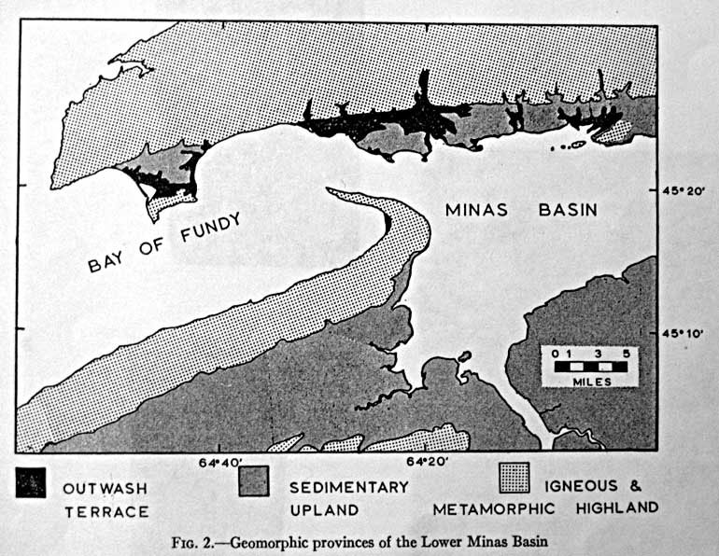

Fig.7: Taken from the article “A Raised Fluviomarine Outwash Terrace, North Shore of the Minas Basin, Nova Scotia”, by Donald J. P Swift and Harold W. Borns, Jr., Journal of Geology, V 75, 1967, p 693

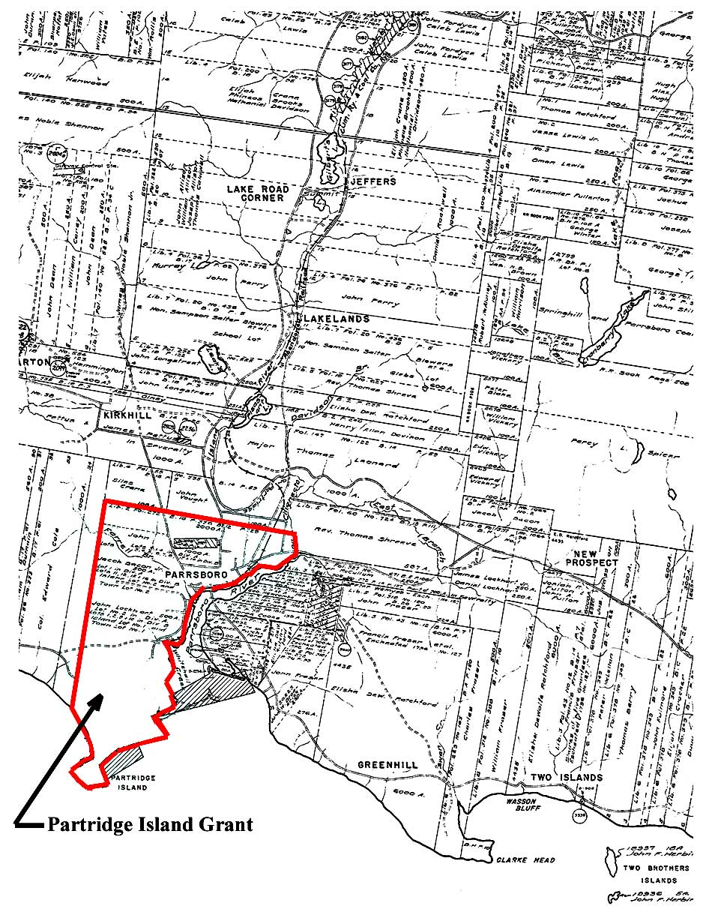

Fig 8. Position of the Partridge Island Grant on the Road to Cumberland.

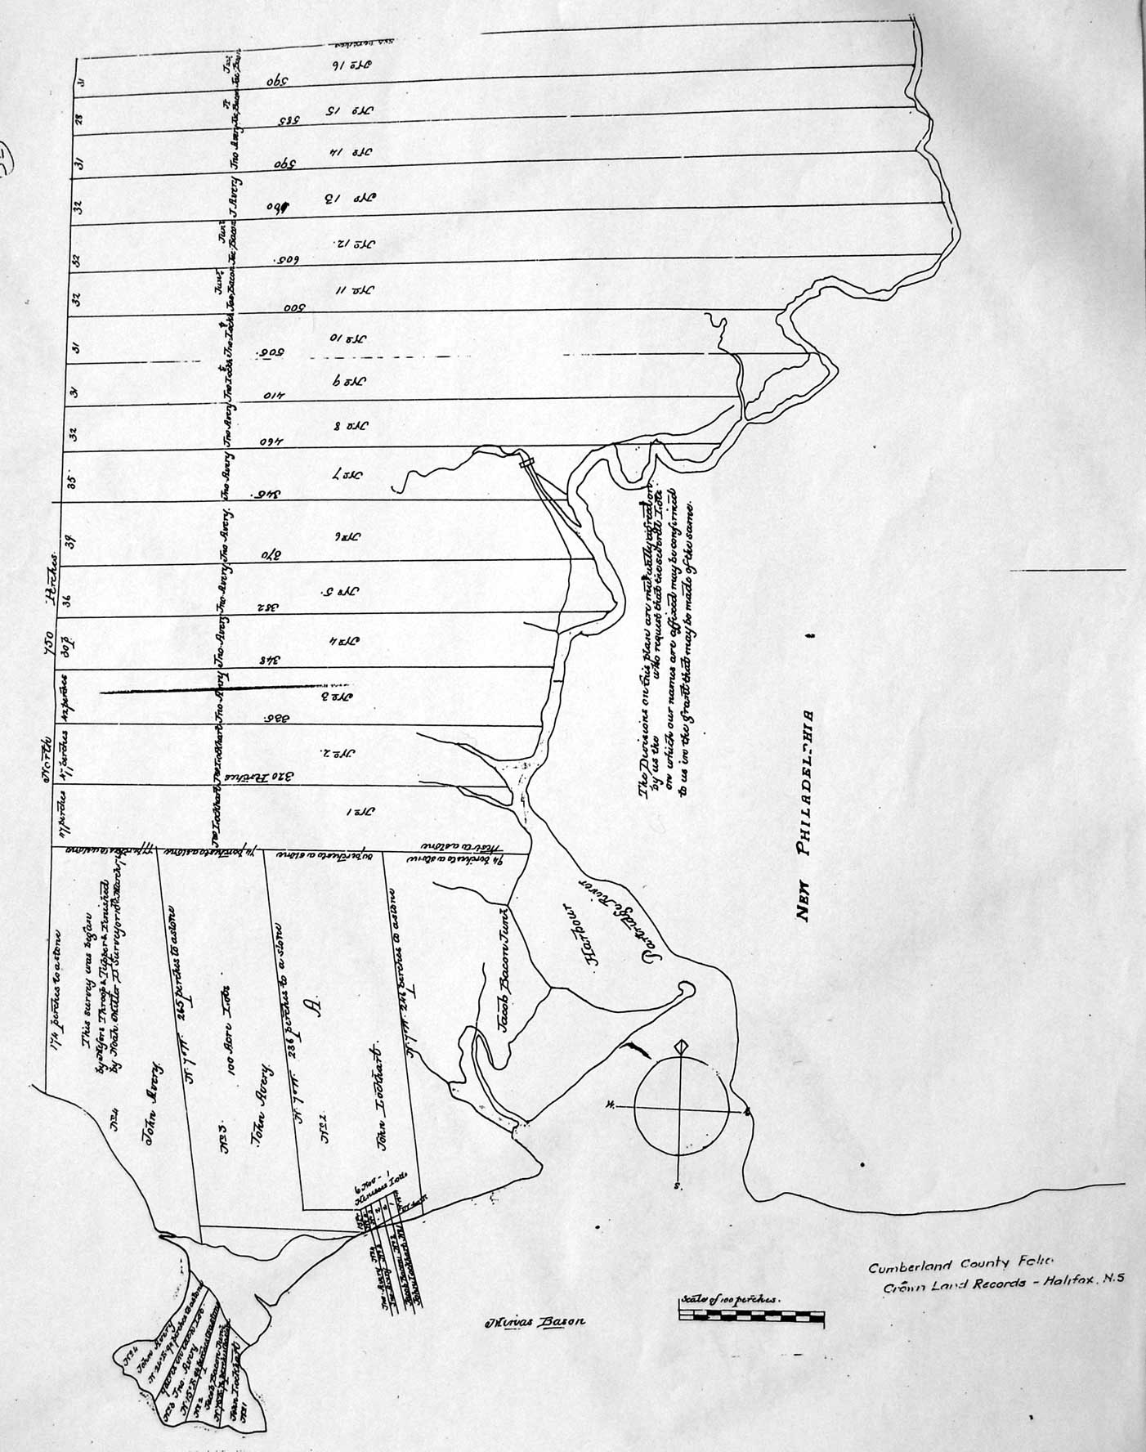

Fig. 9: 1767 (1769?) Surveyor’s Drawing for the Partridge Island Grant.

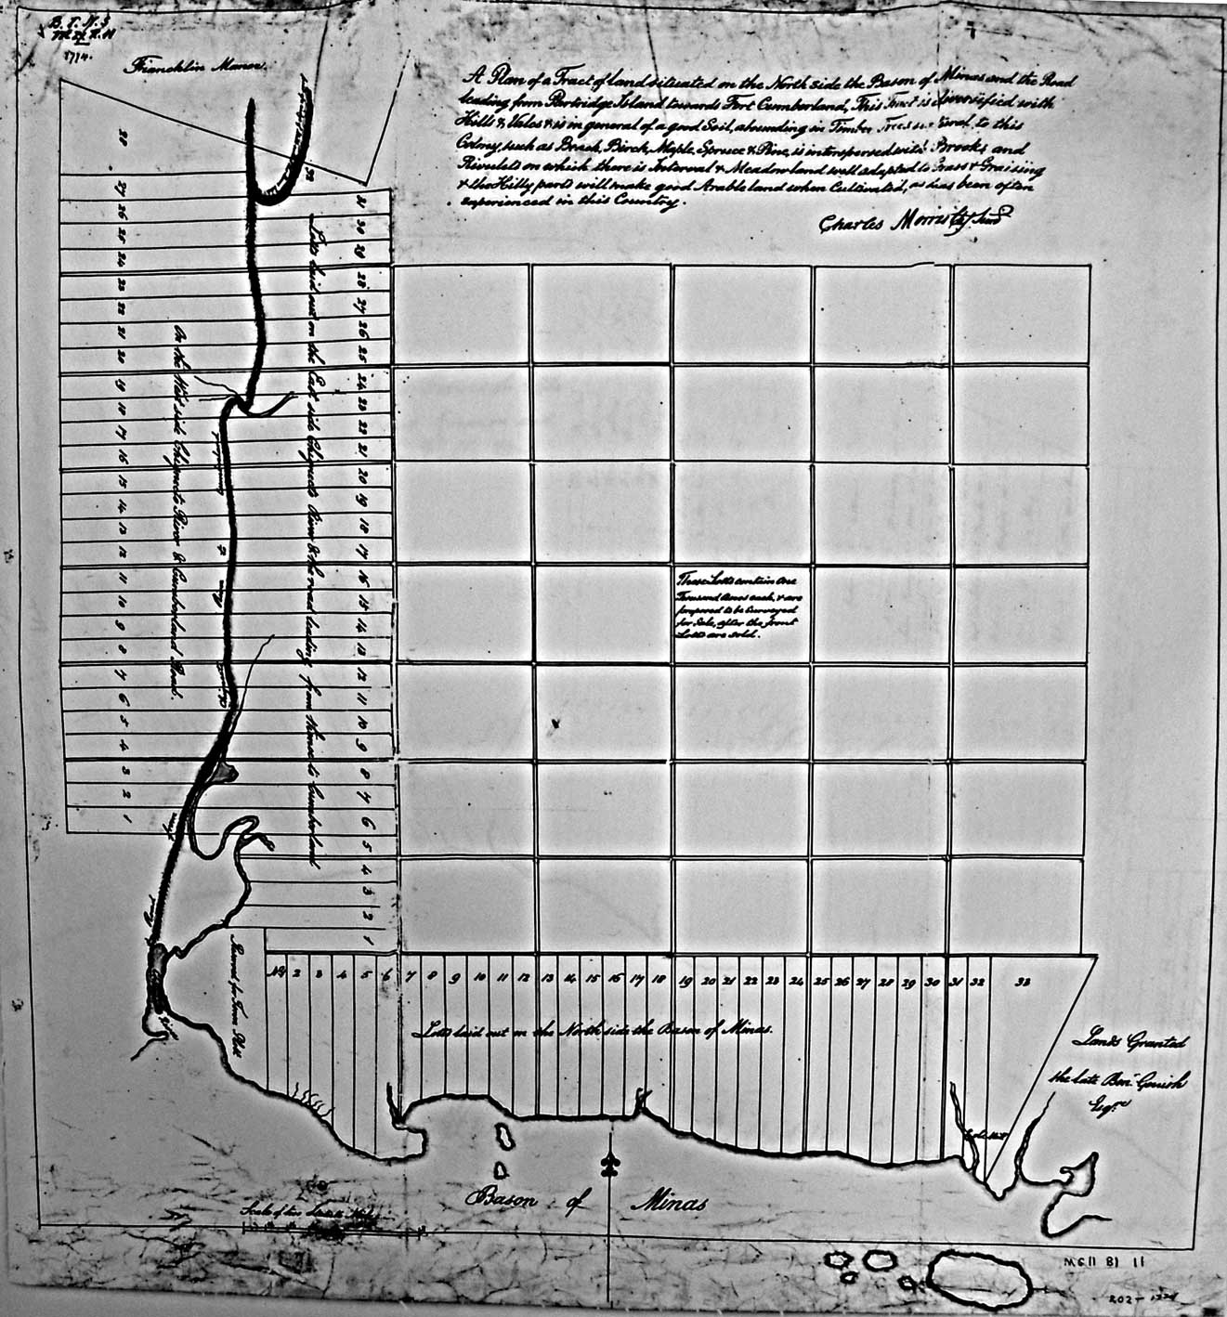

Fig. 10: Grant lots on the Road to Cumberland from the Mouth of the Chignecto River to Francklin’s Manor

Appendix A: The Tobigan

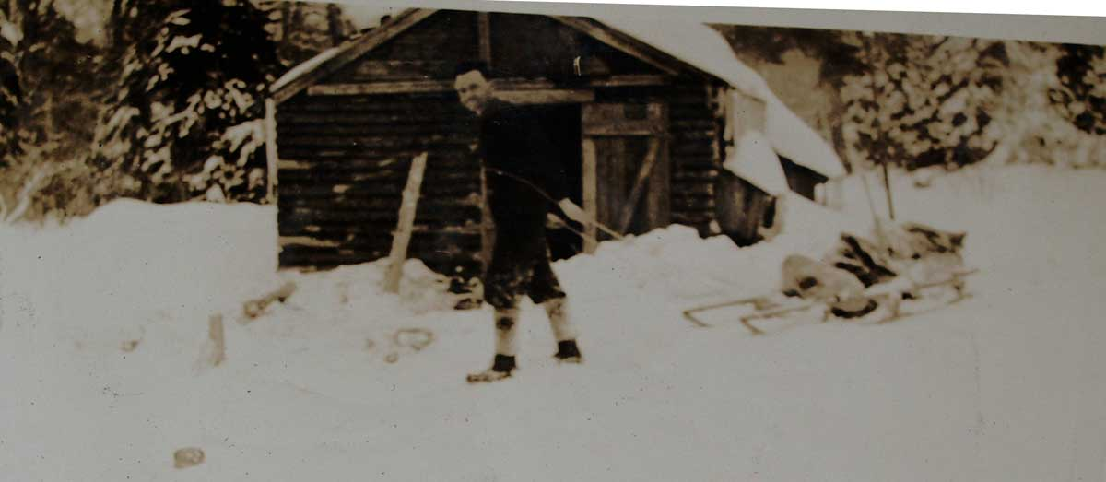

While growing up in Parrsboro during the 1940’s and 1950’s, I often accompanied my father on trips to our “timberland” located five miles north of Port Greville. The trips were made to cut fire wood, logs, and long “timbers” that my father used in the Canning Family business that involved moving houses (Parker 2009,p.159). It was often necessary to spend several days in a small camp on the property. During the winter several miles of the narrow woods road to our property were unplowed and supplies were hauled to the camp on a special sled called a tobigan (pronounced toby-gun). The runners for the sled were as wide as skis and all parts of the sled were fastened together by wooden pins. My father said that tobigans were handmade and that most woodlot owners used them at onetime. He also thought that they were originally designed and made by the Mi’kmaq.

With the exception of a few surviving men and women who were involved in traditional lumber practices, the tobigan is all but forgotten. This is unfortunate since it had an elegant and artistic appearance; it was very functional with a clever design. A few pages are devoted to the tobigan in the publication Older Ways: Traditional Nova Scotia Craftsmen (Barss,1980).

On my behalf, Gerald Gloade, Program Development Officer for Mi'kmaq Museums and Cultural Centres, asked the Mikmawey Debert Elders Advisory Council if they thought that the tobigan was used by the Mi’kmaq prior to contact with Europeans. The Council’s reply is given below.

Question:
Toboggan = contemporary, Mi’kmaq French/Mi’kmaq English ???
Tobigan, pronounced toby-gun = Sled type with runners ???

“Our Elders feel that the word “Tobigan” is actually the Mi’kmaw word “Po’qikn”. “Po’qikn” meaning “Hole Maker” referring to the drilled and doweled side walls. The Elders said it is of Mi’kmaq origin and we had them
before European contact. And that they were used for furs and supplies”.

1) The Mi’kmaw language is a verb based language. Very detailed in the descriptive meanings of form and function.

Mi’kmaq:
“Toboggan” = Tapaqn, meaning, “to pull or drag along the ground.”
“Sled” = Tapaqanji’j, “ji’j” means “Small”
“Sleigh” = Waqa’sskiaq, tapan
“Slippers” = poqqane’jk, “ji’k” means ”Little”

2) Mi’kmaw Elder Dr. Murdena Marshall, Eskasoni First Nation,
Cape Breton County Nova Scotia (902) 379-2508 said she has 2 of them
at home.

Figures A1, and A2 show a tobigan being used in the 1930’s to haul camp supplies from Advocate to a lumber camp at Eatonville. This two-day over night trip into the camp took place every week because the seven-mile road from Advocate to Eatonville was not plowed during the winter.

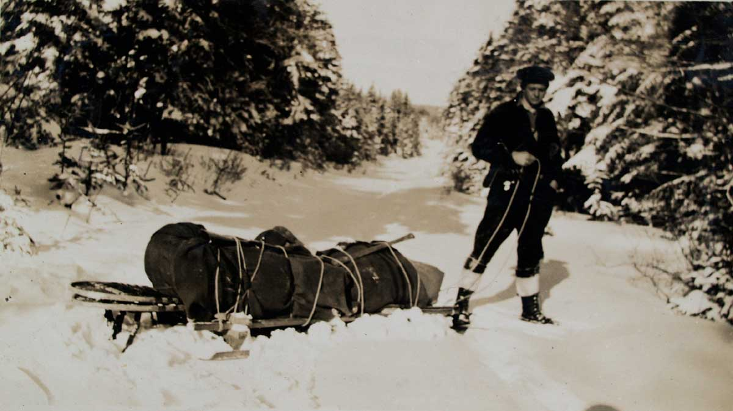

Appendix B
Accounts by Travelers Who Used the Route to Cumberland

Several first person accounts by travelers who used the Road to Cumberland in the eighteenth century have survived. These documents are not always easy to read because they are written in the language of 1700’s. First person accounts are, however, valuable records and if one persists when the language seems strange, interesting historical insights can be gleaned from the documents. This section will give excerpts from two such pieces of writing.

The first item is a letter written in 1791 by the Rev. Hugh Graham of Cornwallis to the Rev. Andrew Brown, D.D. who wishes to visit Cumberland (Graham,1791). Hugh Graham has traveled the Road to Cumberland in the past and he wishes to tell Brown about what to expect while traveling along the road and at the same time a few road related stories. One of Rev. Graham’s stories involves a disturbing encounter between solders and a group of Acadians. Graham’s letter requires perseverance but the rewards make it worthwhile.

The second item is taken from the diary of Henry Alline, a self-taught evangelical preacher from Horton Township (Alline, 1806). In 1781 Alline crosses the Minas Basin and uses the Road to Cumberland to reach several communities north of Amherst. Henry Alline encounters privateers at Partridge Island.

A 1791 letter from the Rev. Hugh Graham
The Nova Scotia Archives and Records Management has a web page displaying material from the Andrew Brown Collection. This material, titled Collections of the Nova Scotia Historical Society, Vol. II (1881); pp. 129-160, contains several transcribed letters written to The Rev. Andrew Brown, D.D. One of these letters, dated 1791, contains detailed information on the "Road to Cumberland". The letter is from the Rev. Hugh Graham of Cornwallis and was written partially to give instructions to Rev. Brown who was planning a trip to Cumberland. Rev. Graham’s letter starts on page 135 but it is not until five pages later, on page 140, that a description of the "Road to Cumberland" can be found.

Rev. Hugh Graham’s description of the "Road to Cumberland" is given below. In his description Rev. Graham digresses twice to tell a story. These informative stories have been removed and placed at the end of this section on Rev. Hugh Graham.

“I understand that you purpose visiting Cumberland this summer, the scene of Watson's youthful years-for he was only between 10 and 12 years of age when he came under Capt. Huston's patronage and lived just about so many in his family. As I have a transient view of that part of the Province, I shall take the liberty of just mentioning a few objects that will naturally engage your attention, excite your enquiries, and more especially as you asked some time ago the notice of my Cumberland tour.
After leaving Partridge Island 17 miles in the rear, for I presume you will travel by land, you will mount what is properly called the Boar's Back, a narrow ridge of land 7 miles in length, and in a few places more than 20 rods in breadth. It stands between a continued narrow swamp on the south-west side, and between swamps, lakes and a river on the north-east side. It is of no great height. It seems to be an entire bed of gravel, and serves as an excellent road. In this instance, as in many others, the hand of nature hath saved man a hard task. Quitting the Boar's Back you will soon reach the head of the river of Herbert Bear. This takes its rise in the lakes on the north-east side of the Boar's Back. It begins to flow by the upper hump and runs about due west. The tide also makes up to the head of the river, so that the Boar may alternately drink salt water and fresh in the course of every day…………… (digresses to tell a story: Story One)……………………………………..
Excuse this digression. My zeal to be of some service to you makes me write several things which, upon reflection, I am apt to think can be of little or no service. At the head of Bear River you will find one solitary house of entertainment. It may afford some pleasure after you have rode 8 miles without having seen the habitation of man, and when you take into the view that you must ride 10 miles before you come to another. Here you ride along a continued strait of marsh land, about a mile beyond the first house you now pass, occupied by a Lieut. McKecachran, from Isla, lives, Mr. Glenie, brother to Capt. Glenie, late of the artillery department. The captain studied divinity in Edinburgh Hall, and is said to be a gentleman of very shining abilities. Perhaps you know the character. At the rate L1500 he bought that large tract of land lying in 12 miles square on both sides of Bear River, and extending from the head of ye river to the foregoing place. His brother has the charge and management of his improvements. You will find him a sensible, frank, and open-hearted farmer, who will be exceedingly glad to entertain you at his house, and will make you very happy. Below his house, more than a mile, there is a French settlement called Men eu die (Meneudie). In this village there is between 20 and 30 houses and a chapel. There you will find a fragment of the stile and manners of other times, after this you will cross the river in a log canoe, or rather in Glenie's boat upon which you enter the township of Amherst………( digresses to tell another story:Story Two)…………………………… After leaving Amherst the remains of Fort Lawrence by the roadside will attract your attention for a short space. From that you will pass on to Fort Cumberland”.
Rev. Hugh Graham’s digression Story One

“The tide also makes up to the head of the river, so that the Boar may alternately drink salt water and fresh in the course of every day; a branch of this river called Napana was the scene of one of those barbarous outrages which created a distant likeness between Scotia junior and Scotia senior. A party of rangers of a regiment chiefly employed in scouring the country of the deluded French who had unfortunately fallen under the bann of British policy, came upon 4 Frenchmen who had all possible caution, ventured out from their skulking retreats to pick some of the straggling cattle or hidden treasure, The solitary few, the pitiable four, had just sat down weary and faint on the banks of the desert stream in order to refresh themselves with some food and rest, when the party of Rangers surprised and apprehended them, and as there was a bounty on Indian scalps, a blot, too, on England's escutcheon, the soldiers soon made the supplicating signal, the officer's turned their backs, and the French were instantly shot and scalped. A party of the Rangers brought in one day 25 scalps, pretending that they were Indian's, and the commanding officer at the fort, then Col. Wilmot, afterwards Governor Wilmot (a poor tool) gave orders that the bounty should be paid them. Capt. Huston who had at that time the charge of the military chest, objected such proceedings both in the letter and spirit of them. The Colonel told him, that according to law the French were all out of the French; that the bounty on Indian scalps was according to Law, and, that tho' the Law might in some instances be strained a little, yet there was a necessity for winking at such things.Upon account Huston, in obedience to orders, paid down L250, telling them that the curse of God should ever attend such guilty deeds. A considerable large body of the French were one time surprised by a party of the Rangers on Peticodiac River; upon the first alarm most of them threw themselves into the river and swam across, and by ways the greater part of them made out to elude the clutches of these bloody hounds, tho' some of them were shot by the merciless soldiery in the river. It was observed that these Rangers, almost without exception, closed their days in wretchedness, and particularly a Capt. Danks, who even rode to the extreme of his commission in every barbarous proceeding. In the Cumberland insurrection (late war) he was suspected of being Jack on both sides of the bush; left that place, Cumberland, in a small jigger bound for Windsor, was taken ill on the passage, thrown down into the hold among the ballast, was taken out at Windsor, is half dead, and had little better than the burial of a dog. He lived under a general dislike and died without any to regret his death. Excuse this digression. My zeal to be of some service to you makes me write several things which, upon reflection, I am apt to think can be of little or no service.”

Rev. Hugh Graham’s digression Story Two

The 2nd house on your way is occupied by one emphatically called Forrest, the rich man. It will not be amiss to give him a call. He is a curiosity. He is the unpolished rustic; has, however, a large share of natural sense blended with a very gross vein of drollery. He is one of a small congregation of Irish Pbns. who will gladly and gratefully attend on your salutory instructions on the sacred day when the call is Let us go up to the House of the Lord. There is among them a Mr. McGowan, an elder, a worthy and agreeable man. They have built a decent little meeting-house, have made several attempts to get a minister, and after repeated disappointments, it is said one will be sent them from Scotland this summer — one of Mr. McGregor's class. But if he does come I fear it will be too late to do much good, or to live with any manner of comfort in that place. There are not now above a dozen of professed Pbn. families in the whole settlement. After leaving Amherst the remains of Fort Lawrence by the roadside will attract your attention for a short space. From that you will pass on to Fort Cumberland.”

Henry Alline: The traveling preacher from Horton Township

Henry Alline, 1748 – 1784 and his parents were New England Planters who settled in Horton Township in 1760. From 1776 until his death in 1784 Henry Alline was an independent and self-taught evangelical preacher who traveled to various parts of Nova Scotia giving sermons in barns and people’s homes. His published diary contains brief notes that provide a small but significant amount of information on the “Road to Cumberland” and on Partridge Island. They confirm, for example, that some travelers did cross over the mouth of the River Hebert to Amherst Point. As well, Henry Alline’s diary confirms that enemy privateers did visit Partridge Island during the American Revolution. Excerpts relevant to this paper will now be presented.

On August 7, 1781 Henry Alline was in Windsor waiting for a vessel to take him to Partridge Island. His diary entry reads:

“The vessel that I had been waiting for to go to the county of Cumberland was now in. I went on board her, and the same day we sailed, after I had bid my friends a farewell, promising to return to them as soon as possible. We lay in the Basin of Minas all that night. About midnight there was a terrible thunderstorm, but the Lord was kind to me, blessed be his name for it”.

The next day he wrote:

“On Sabbath Day I got to Partridge Island and preached there about seven in the morning to what people were there. They were about 20 in number, and seemed to give great attention to the word preached, and my own soul was blessed. And great, yea great was God’s goodness to me. O that I could love him with all my soul”!

On Aug.9 1781 Henry Alline must have left Partridge Island alone on horseback and followed the “Road to Cumberland” because his diary entry states that “ I rode through the woods about 50 miles to where it was inhabited. I was in a strange place, where I never had been before: but O the Lord remembered his poor unworthy servant, and gave me many blessed moments when riding alone”.
Presumably Alline arrived somewhere between the present-day communities of River Hebert and Minudie because after preaching on the 10th of August he wrote in his diary the next day “I crossed the River to Amherst Point, and preached there in the evening”.

After reaching Amherst Point Henry Alline traveled to various settlements in the Amherst, Sackville, and Petit Codiack River regions of 1781 Cumberland County; New Brunswick would not be established until August 16, 1784. After preaching at these communities Alline returned to the Amherst area and on Sept. 20, 1781 he wrote in his diary “Road about 10 miles and crossed the river”. His diary entry for the next day reads; “I then rode to Partridge Island”.

Henry Alline was still in Partridge Island on the morning of Sept. 22, 1781 and his diary entry for that day is very significant for Partridge Island history. The diary reads:

“Sept. 22, 1781: This morning about break of day I was called out of my bed, and carried onboard a privateer, but not out of any ill will to me, only they found, there was such a man there with a horse, and they, intending to take some vessels from out of the basin, were afraid that I should carry back intelligence to Cumberland before they had got ready to sail from that harbour. When I came on board, the captain told me I should suffer no injury, but have whatever I wanted, and be put ashore again as soon as they had taken three prizes. Let them that wish well to their soils flee from privateers as they would from the jaws of hell, for methinks a privateer may be called a floating hell”.

Alline ‘s experience onboard the privateer must not have been too traumatic because on Sept. 23, 1781 he wrote “I enjoyed this day some happy moments at my pen and likewise in my private walks about the island. I much acknowledge, the kindness of God to me is great”.

The next day Henry Alline left Partridge Island. His entry states “I was this day in an open boat put across the basin to Horton, and left my horse behind me on Partridge Island, the ferry boat not being there”.

The Road to Cumberland has many stories that have long ago passed out of memory and were never recorded for posterity. Some, like the two given above, have been preserved and hopefully more will surface in the future.

References

